Location
Sun City Grand is a Del Webb master-planned community for active adults age 55 and better. It is located 18 miles northwest of Phoenix, in the City of Surprise, Arizona.

Size and Population
There are approximately 9,800 residential homes on nearly 4,000 acres of land. Over 17,000 residents call Sun City Grand home. Sun City Grand opened for sales in 1996.

Village Center/Recreational Amenities
The beautifully designed Village Center is the recreation focal point of the community. It features the Adobe Spa & Fitness Center, Chaparral Center, Sonoran Plaza and Artisan Studios.

The Adobe Spa & Fitness Center includes a heated indoor lap pool, an outdoor resort swimming pool and outdoor activity pool, indoor and outdoor spas, indoor walking track, fully equipped health and fitness area, a dance/exercise studio, plus tennis and bocce courts. Staff members from Sun Health are on-site at the fitness center to provide a variety of health and wellness services for our residents.

The Chaparral Center is home to the ASU West Lifelong Learning Academy, Joe Zuni’s gourmet coffeehouse, extensive computer lab, hi-tech video lab and business services.

Ideally suited for social activities, the Sonoran Plaza features a 9,000 square foot ballroom, a library and multiple meeting rooms.

The Artisan Studios accommodate a wide range of interest to serve the needs and desires of our residents. Stained glass, billiards, ceramics, sewing and art are all available there.

The Cimarron Center is located among the newest neighborhoods of our community. The Cimarron Center houses a fully equipped health and fitness area, a heated outdoor resort swimming pool and the Cimarron Day Spa. Also anchored to this 35,000 square foot facility is the Cimarron Golf Club, opened in 2003.

Other amenities that can be found throughout the community include a woodworking shop, the Del E. Webb Memorial Ball Field, a fishing dock, outdoor amphitheater and extensive walking trails.

Golf
There are 4 golf courses at Sun City Grand, all of which were designed by Billy Casper and Greg Nash. The Cimarron Golf Club opened in the spring of 2003. Residents enjoy reduced daily green fees.

Shopping and Entertainment
Located in and around Sun City Grand are an abundant choice of banks, grocery stores, restaurants, and cultural attractions. Arrowhead Shopping Mall is a convenient eight miles away, offering 135 retail stores and a 14-theater complex. Sun City Grand is located near Phoenix, which offers all the sporting events and cultural attractions that you would expect in a major metropolitan city.

Health Care
Located adjacent to Sun City Grand is Sun Health Del E. Webb Memorial Hospital, a 203 bed facility. Sun Health Boswell Memorial with 324 beds is located in neighboring Sun City. In addition, there are a variety of medical clinics, private practices, nursing and rehabilitation centers nearby.

Police and Fire Protection
Sun City Grand is located in the City of Surprise and is served by its police and fire departments. A volunteer citizens’ patrol also operates throughout the city, in conjunction with the police department. A camera surveillance system monitors vehicular traffic access at the primary entrances to the community.

Lifelong Learning
Sun City Grand has partnered with ASU West to bring the ASU West Lifelong Learning Academy on site. Located in the Chaparral Center, the academy offers year-round academic focused classes, seminars, lectures and discussion groups exclusively for residents.

Sun City Grand
92Series: 2001-Present

Similar
Model Name Sq. Ft. Models
S9210 Iris 1,120
S9211 Cypress 1,246 Willow
S9212 Cactus Flower 1,409
S9213 Azalea 1,482
S9214 Sycamore 1,688 Madera
S9215 Desert Rose 1,814 Verde
P9231 Borgata 1,852 Palo Verde & *Prescott
P9232 Valencia 1,920 Cholla & *Flagstaff
P9233 Sierra 1,997 Coronado
P9234 Verano 2,133 Verbena & *Catalina
P9235 Mission 2,260
P9236 Hacienda 2,314 Stonecrest & *Lakeside
E9251 Ashbury 2,439
E9252 Cambridge 2,627 Rosewood
E9253 Hampton 2,808 Mesquite
E9254 Kensington 2,988 Briarwood
E9255 Windsor 3,388

ASSOCIATION HOMES
C9221 Celebration 1,161
C9222 Legacy 1,284
C9223 Heritage 1,392
*SCW Plan

Sun City Grand
91 Series: 1997-2001

Similar
Model Name Sq. Ft. Models
S9161 Willow 1,115 Cypress
S9162 Kiva 1,267
S9163 Acacia 1,405
P9101 Sonoma 1,416
P9102 Lantana 1,532 *Havasu
S9164 Madera 1,612 Sycamore
P9103 Manzanita 1,695 *Safford
S9165 Verde 1,767 Desert Rose
P9104 Palo Verde 1,836 Borgata & *Prescott
P9109 Cholla 1,916 Valencia II & *Flagstaff
P9110 Coronado 1,996 Sierra
P9105 Verbena 2,019 Verano & *Catalina
P9106 Stonecrest 2,170 Hacienda & *Lakeside
P9107 Windrose I 2,259 *Sedona
Windrose II 2,456
E9130 Saguaro 2,290
P9108 Jasmine 2,410 *San Carlos
E9131 Cordova 2,531 *Somerton
E9135 Rosewood 2,585 Cambridge
E9133 Ironwood 2,732
E9132 Mesquite 2,779 Hampton
E9136 Briarwood 2,965 Kennsington
E9134 Hearthstone 2,986 *Scottsdale

ASSOCIATION HOMES
C9151 Monterra 1,096
C9152 Silverstone 1,222
C9153 Sundance 1,303
C9154 Mariposa 1,441
G9171 Cedar 1,097
G9172 Sage 1,313
G9173 Juniper 1,484
*SCW Plan
Grand Floor Plans 1997-Present
Sun City Grand
91 Series: 1997-2001

Similar
Model Name Sq. Ft. Models
S9161 Willow 1,115 Cypress
S9162 Kiva 1,267
S9163 Acacia 1,405
P9101 Sonoma 1,416
P9102 Lantana 1,532 *Havasu
S9164 Madera 1,612 Sycamore
P9103 Manzanita 1,695 *Safford
S9165 Verde 1,767 Desert Rose
P9104 Palo Verde 1,836 Borgata & *Prescott
P9109 Cholla 1,916 Valencia II & *Flagstaff
P9110 Coronado 1,996 Sierra
P9105 Verbena 2,019 Verano & *Catalina
P9106 Stonecrest 2,170 Hacienda & *Lakeside
P9107 Windrose I 2,259 *Sedona
Windrose II 2,456
E9130 Saguaro 2,290
P9108 Jasmine 2,410 *San Carlos
E9131 Cordova 2,531 *Somerton
E9135 Rosewood 2,585 Cambridge
E9133 Ironwood 2,732
E9132 Mesquite 2,779 Hampton
E9136 Briarwood 2,965 Kennsington
E9134 Hearthstone 2,986 *Scottsdale

ASSOCIATION HOMES
C9151 Monterra 1,096
C9152 Silverstone 1,222
C9153 Sundance 1,303
C9154 Mariposa 1,441
G9171 Cedar 1,097
G9172 Sage 1,313
G9173 Juniper 1,484
*SCW Plan
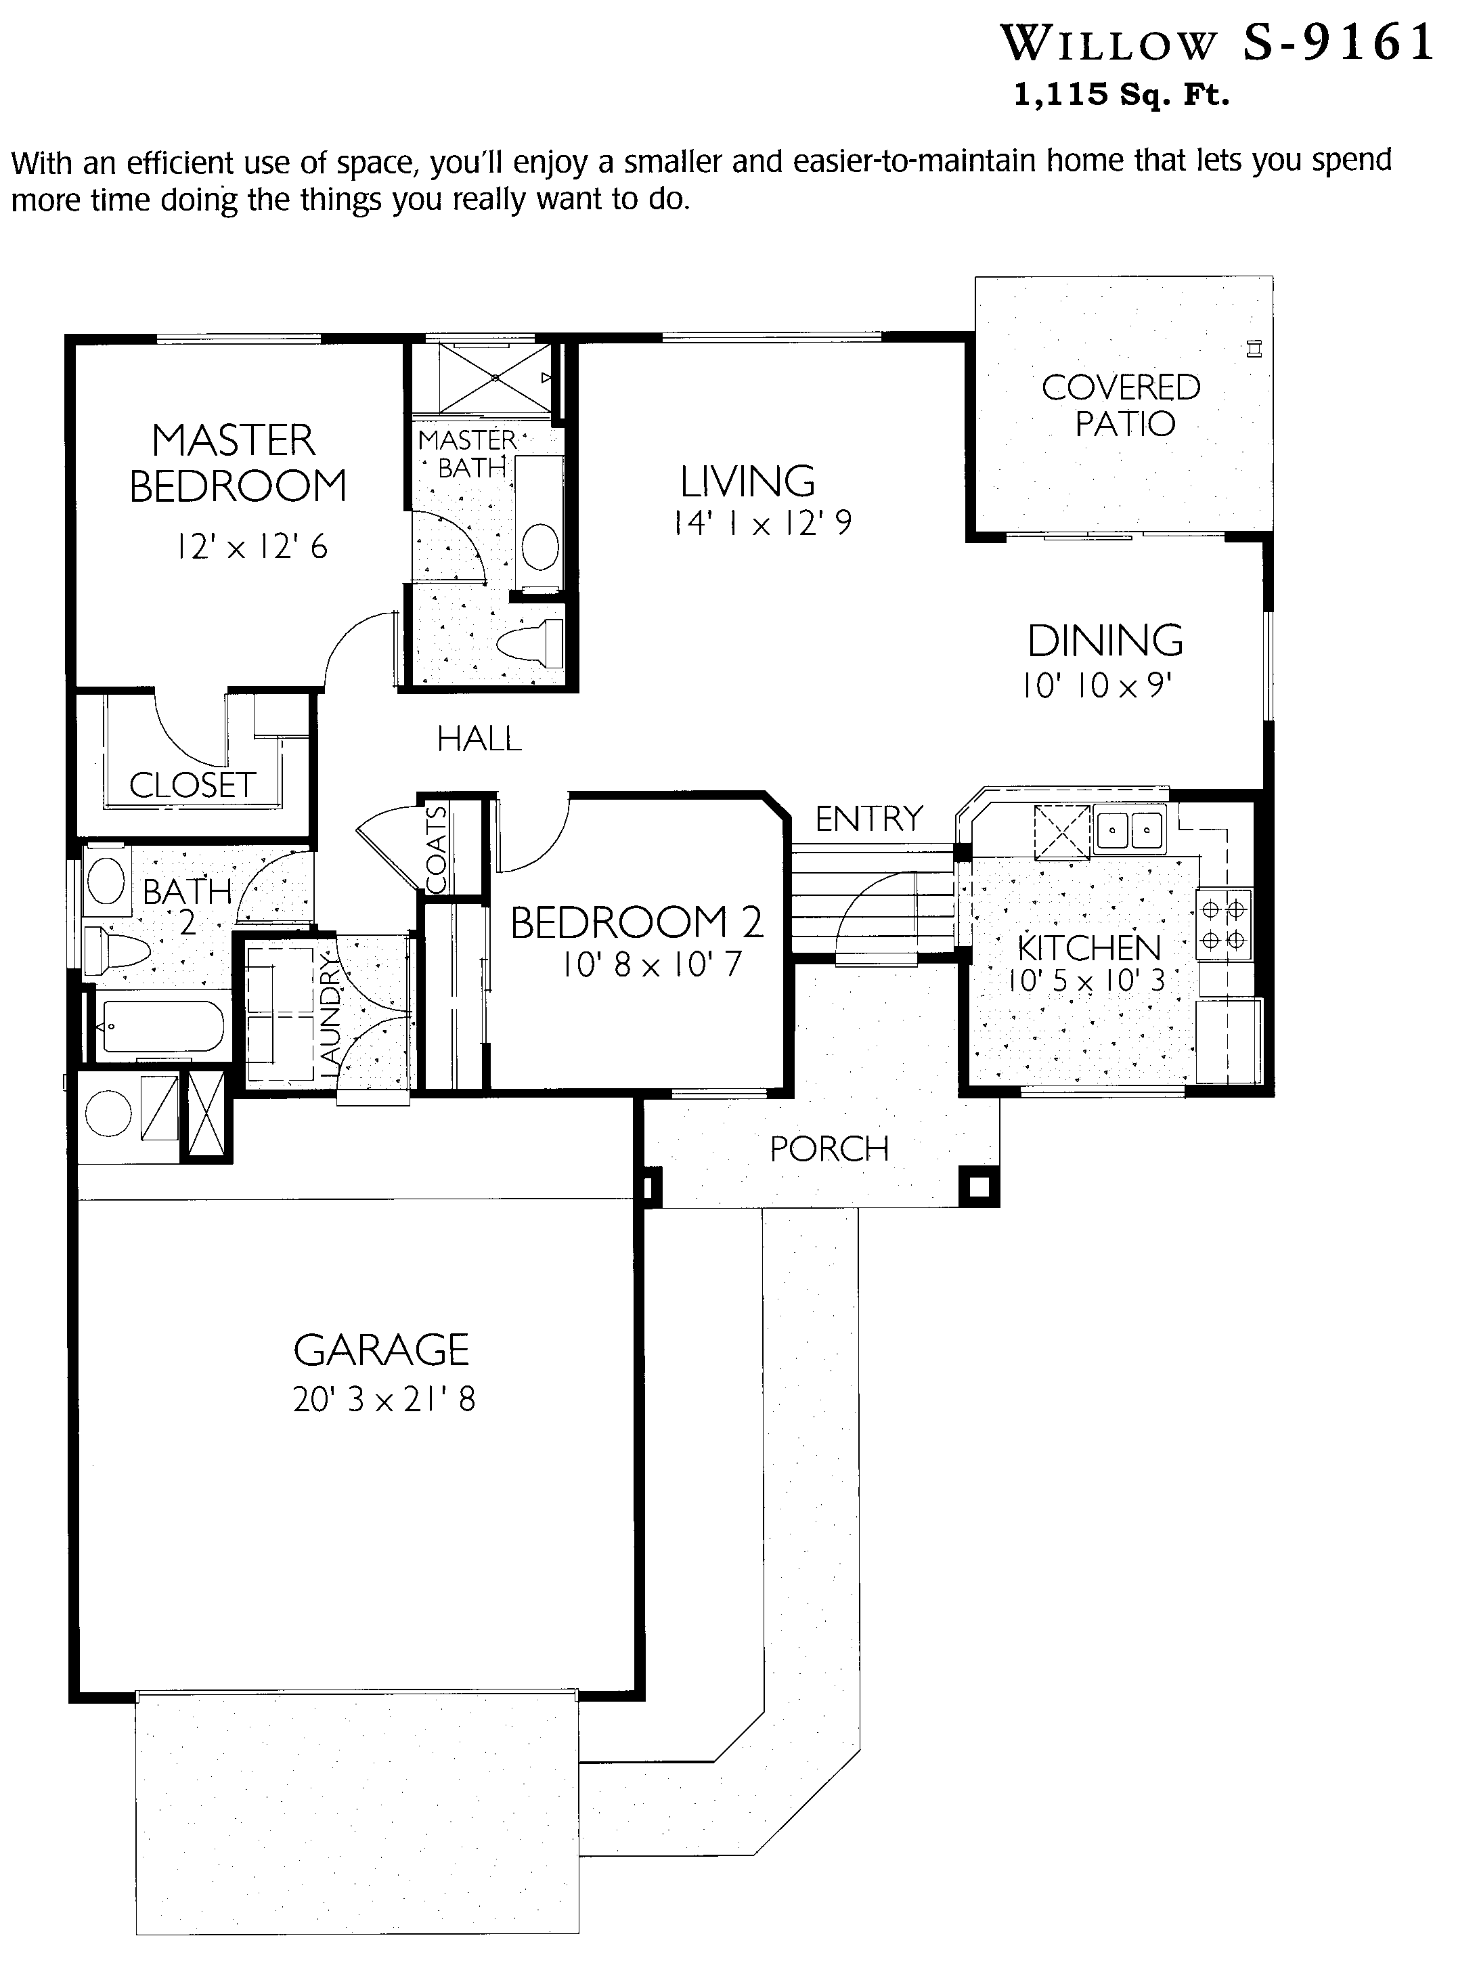
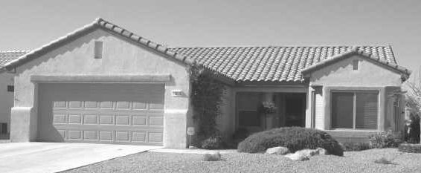
Lynn Verheul
623/221-5171
Similar Floor Plan: Cypress
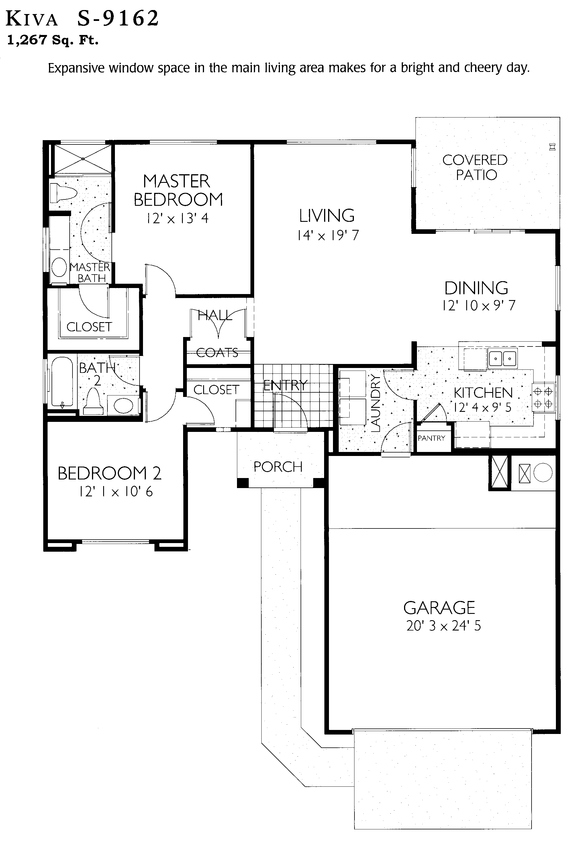
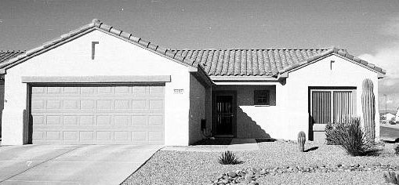
Lynn Verheul
623/221-5171

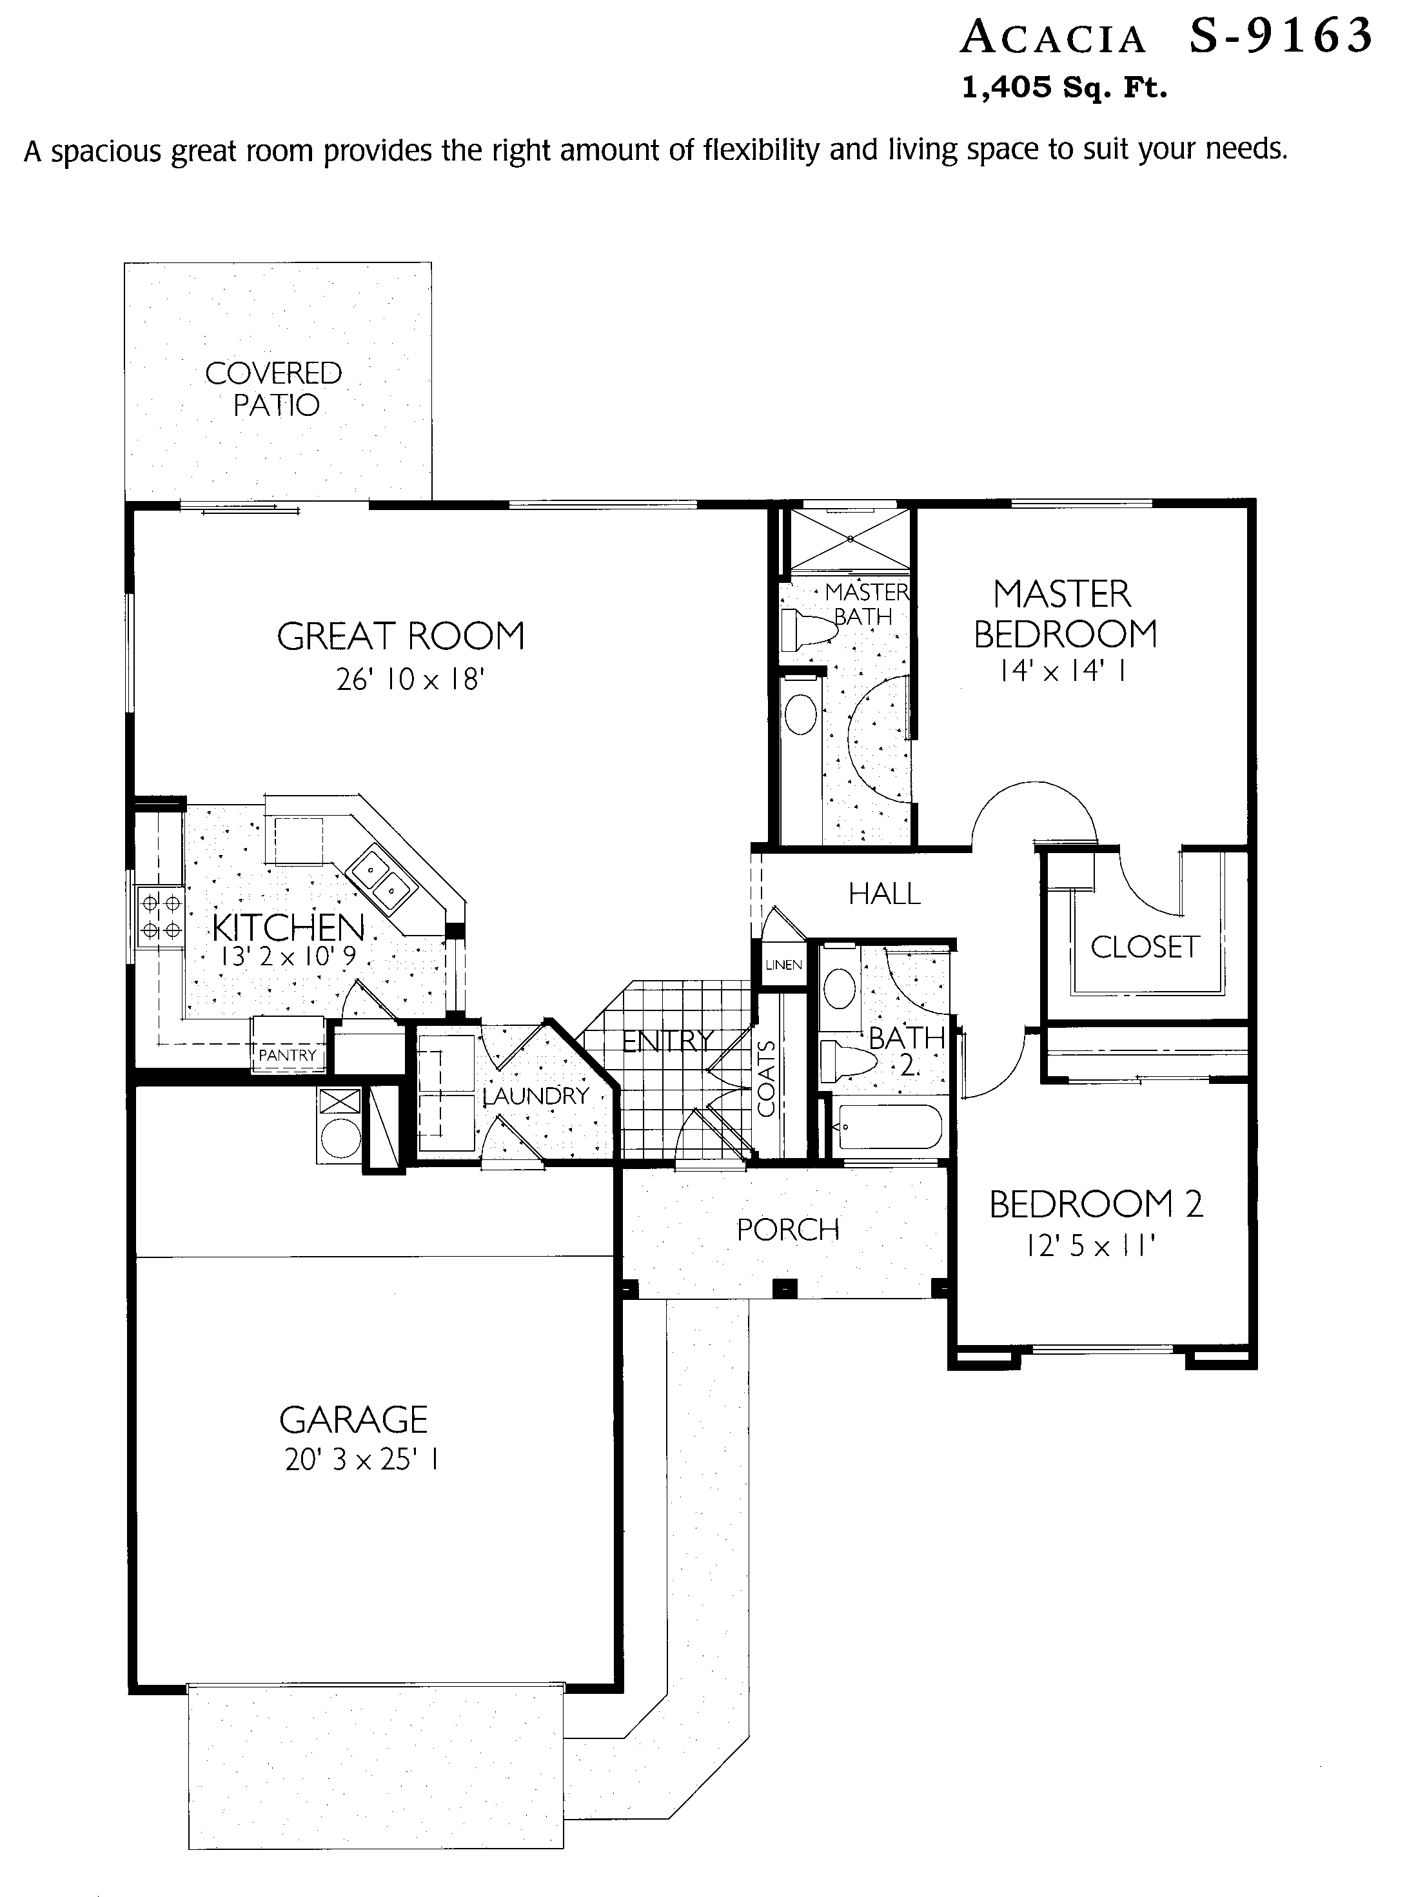
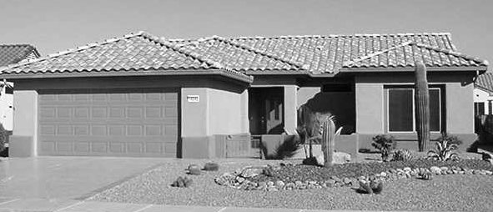
Lynn Verheul
623/221-5171

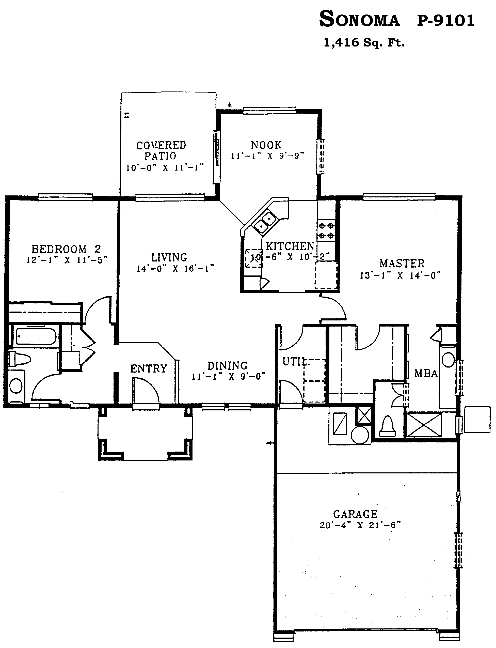
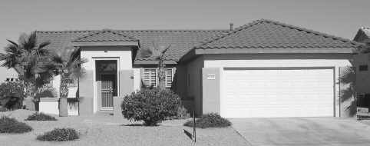
Lynn Verheul
623/221-5171

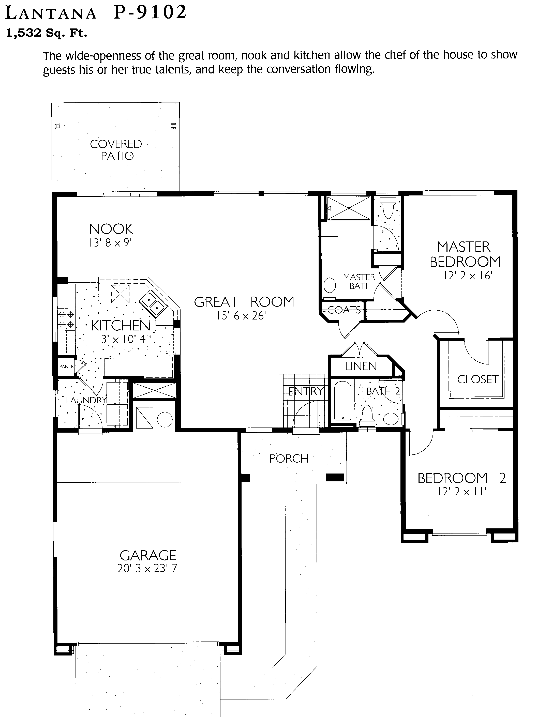
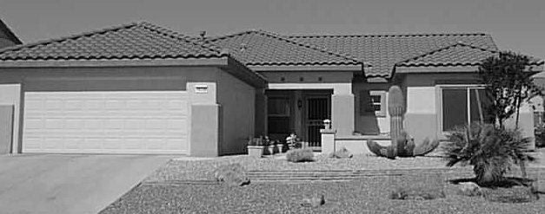
Lynn Verheul
623/221-5171

Similar Plan: *Havasu
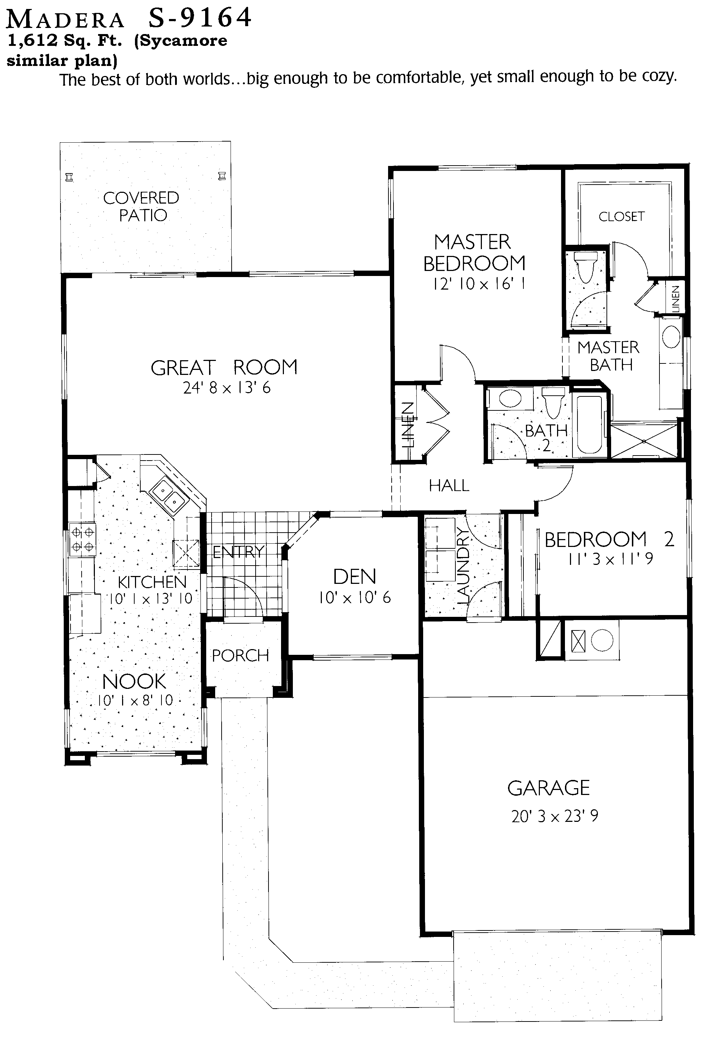
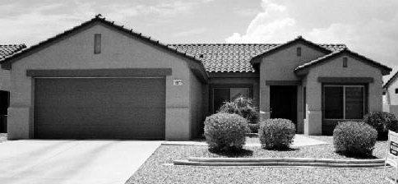
Lynn Verheul
623/221-5171

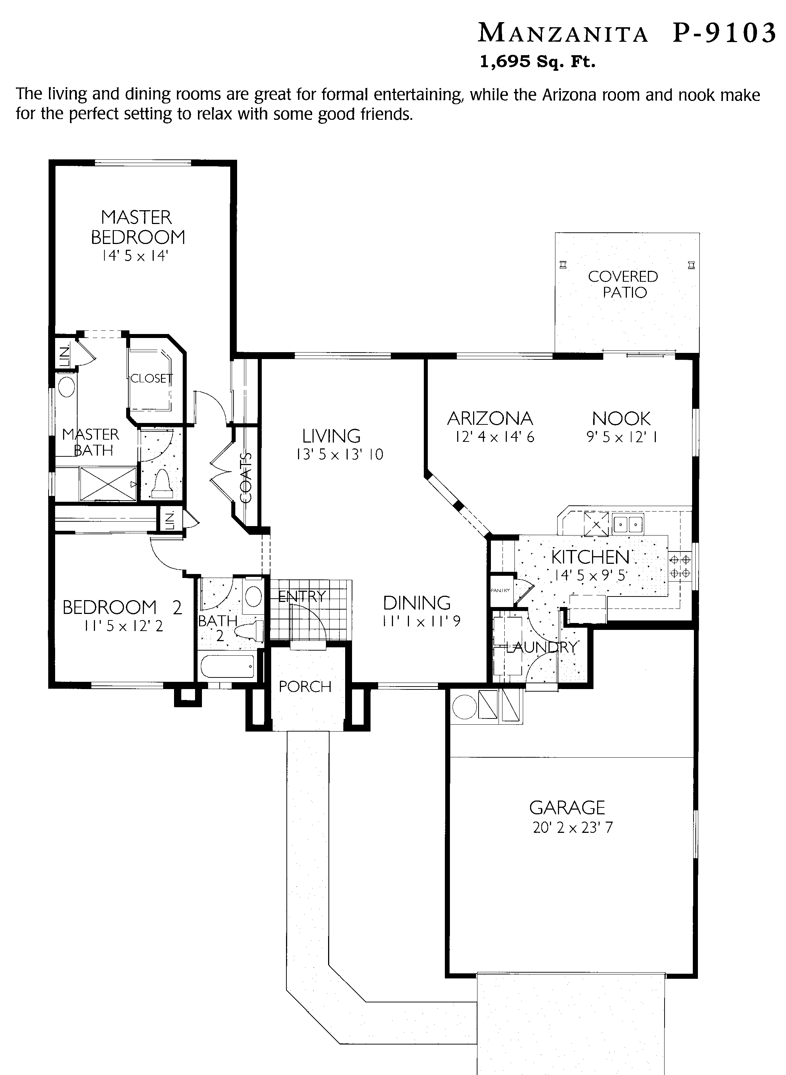
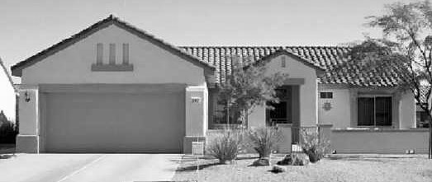
Lynn Verheul
623/221-5171

Similar Plan: *Safford
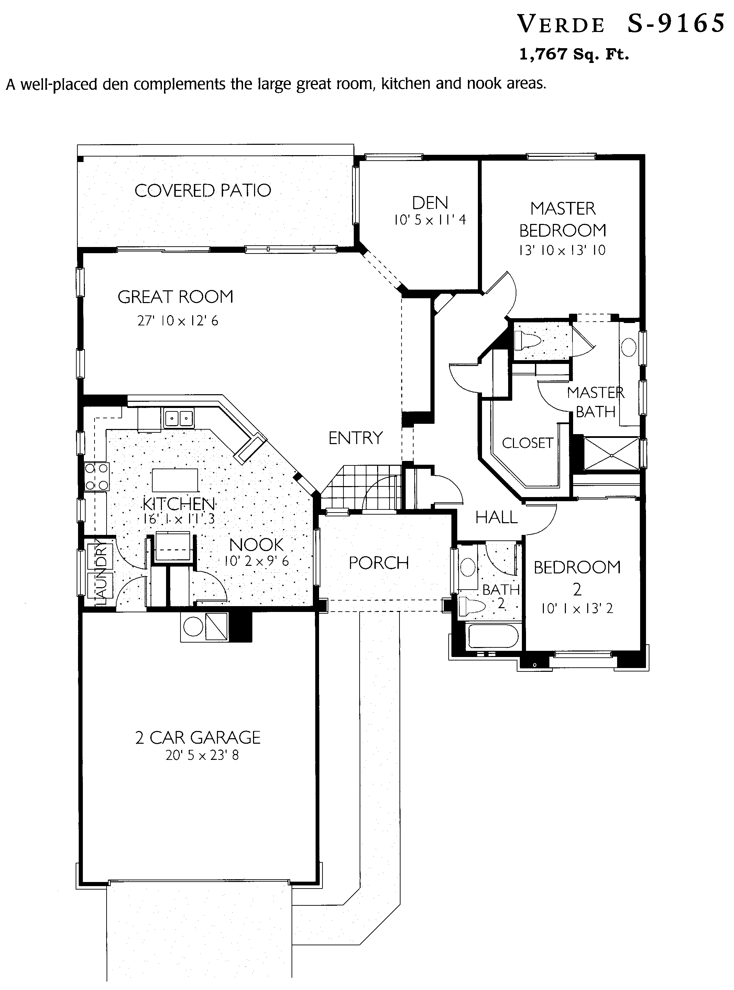
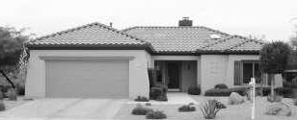
Lynn Verheul
623/221-5171

Similar Plan: Desert Rose
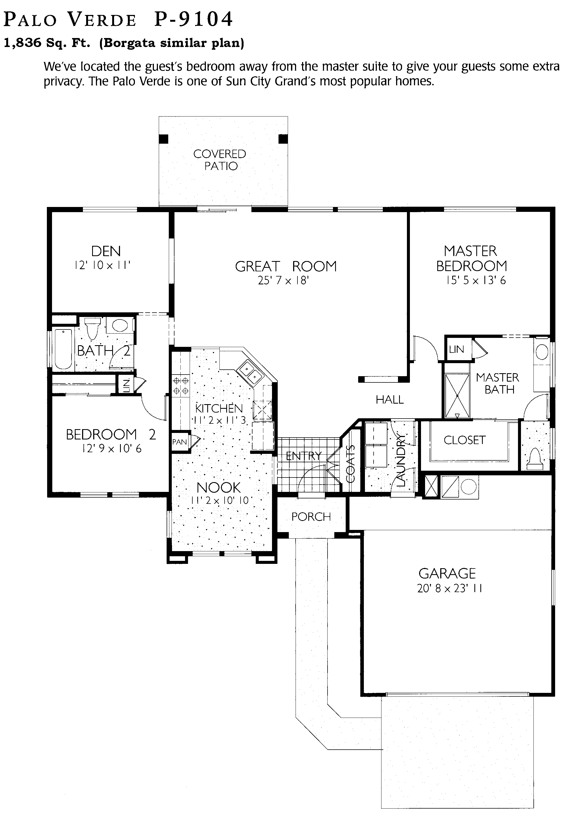
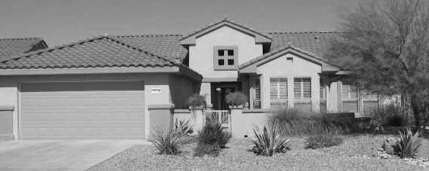
Lynn Verheul
623/221-5171

Similar Plan: Borgata, *Prescott
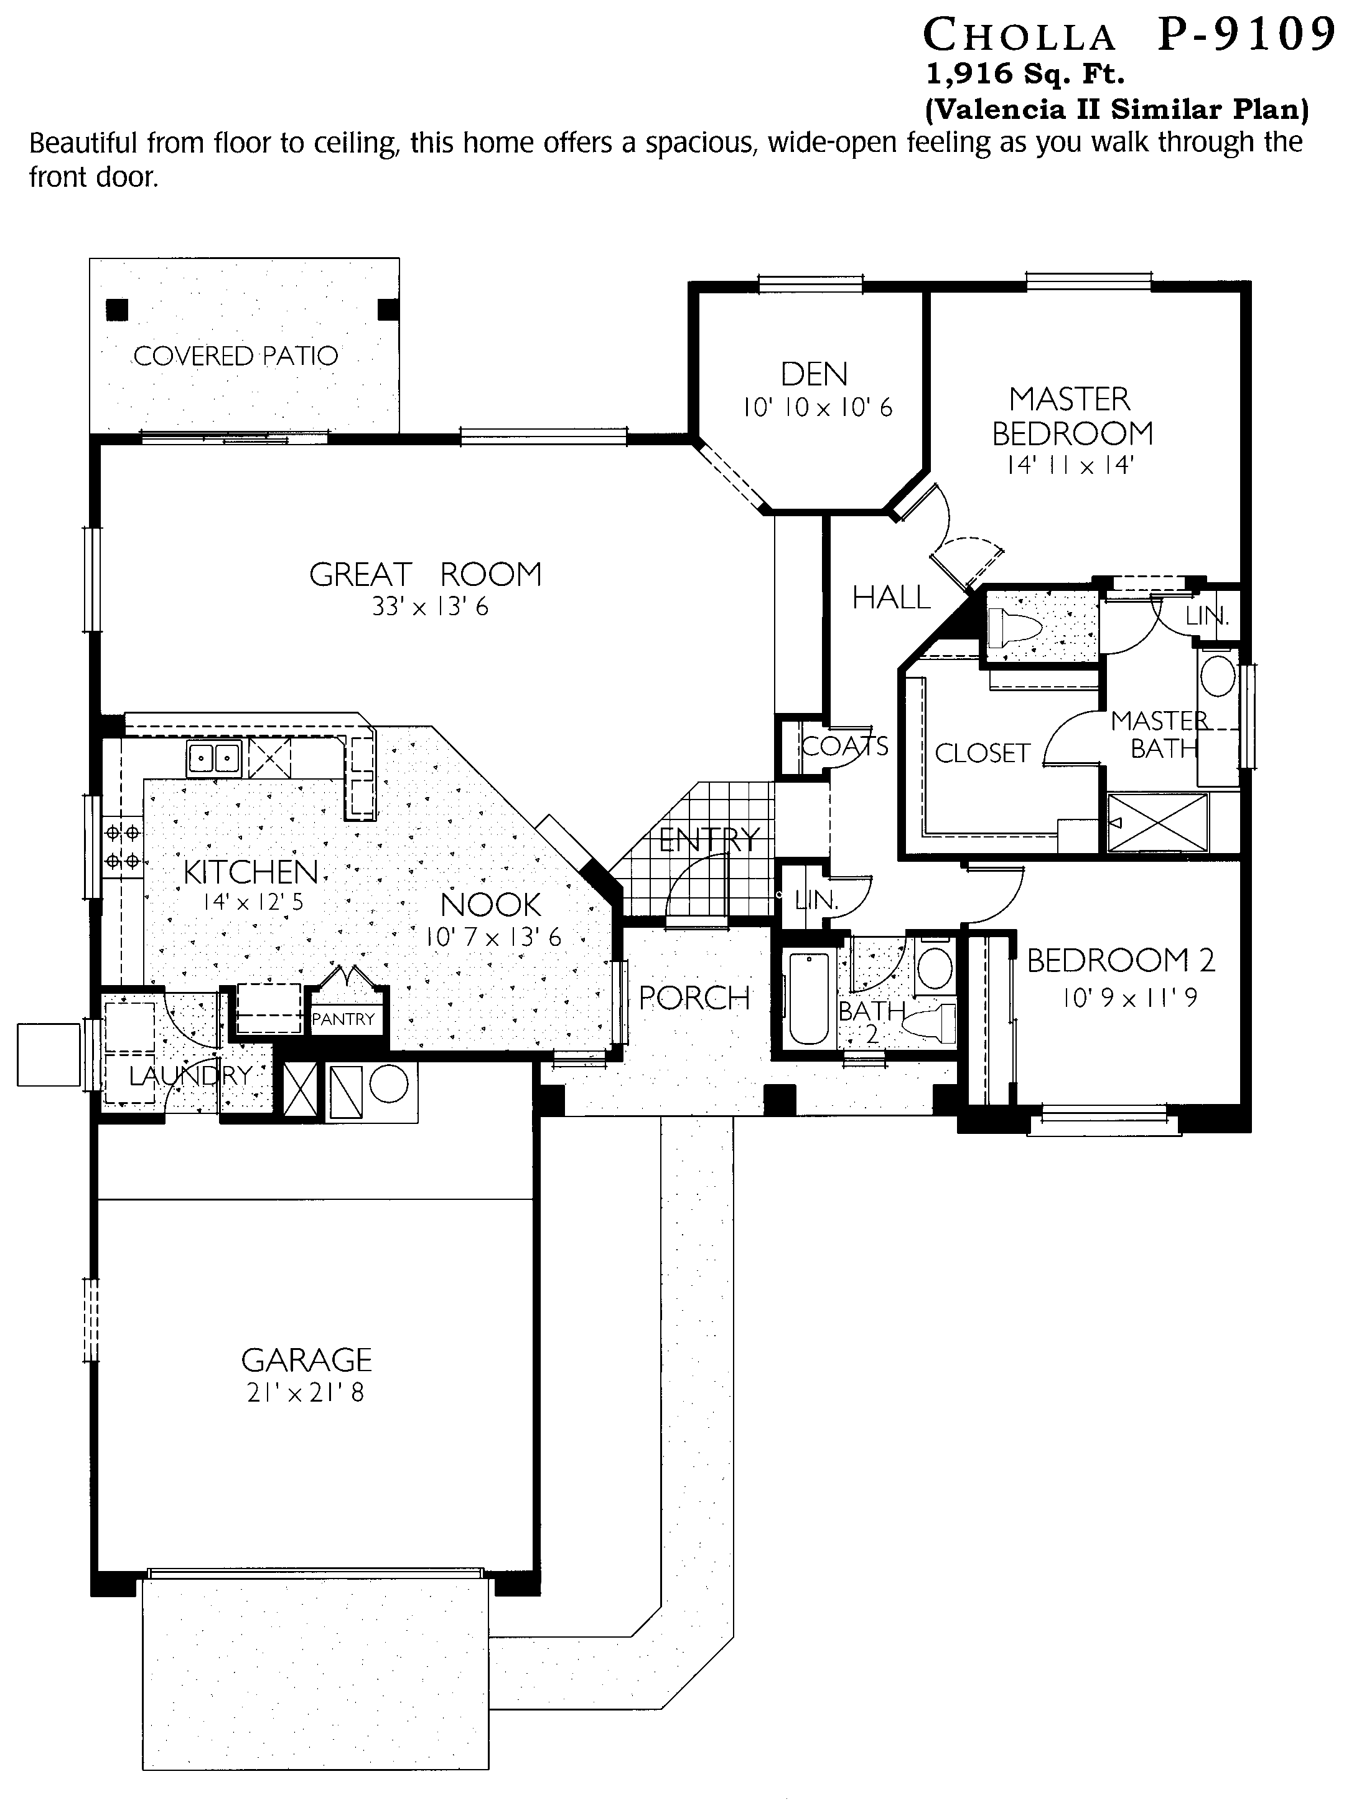
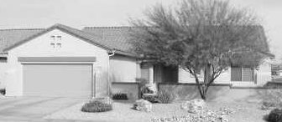
Lynn Verheul
623/221-5171

Similar Plan: Valencia II, *Flagstaff
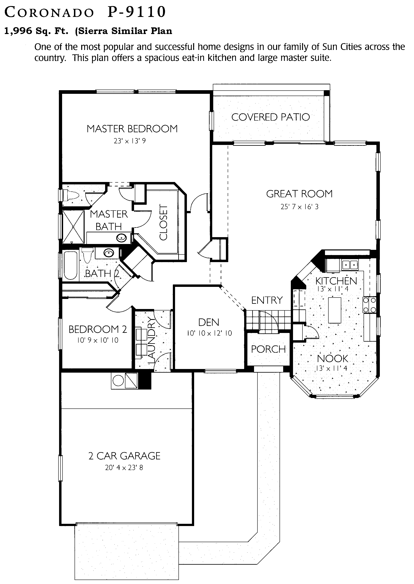
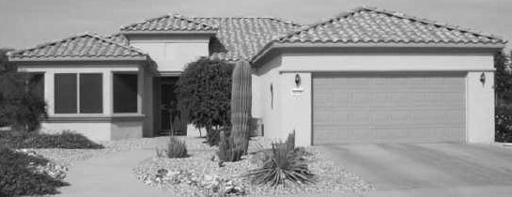
Lynn Verheul
623/221-5171

Similar Plan: Sierra
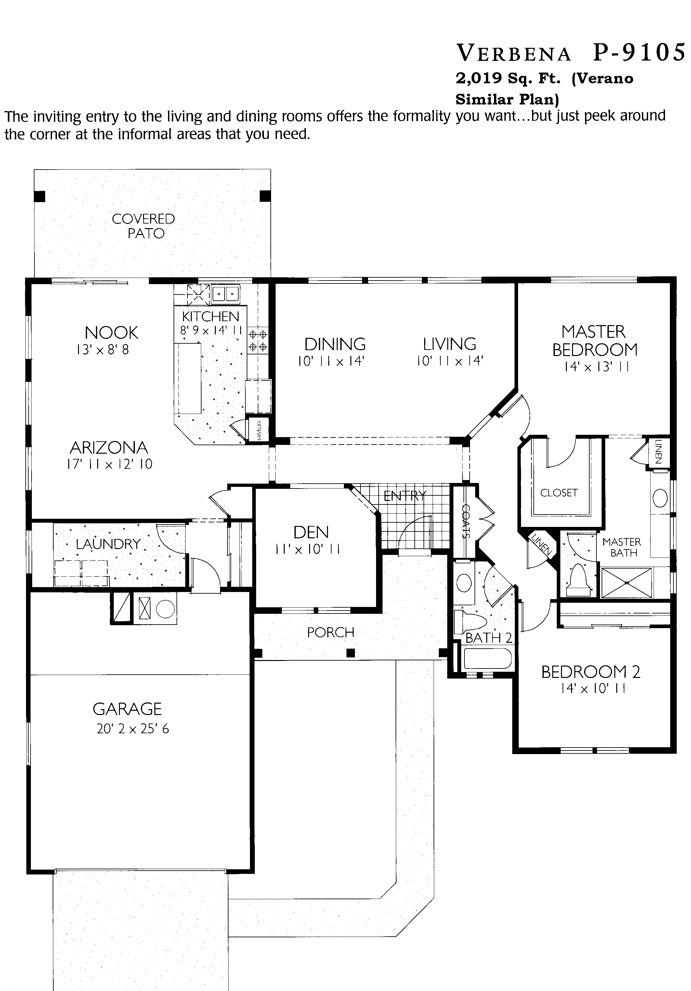
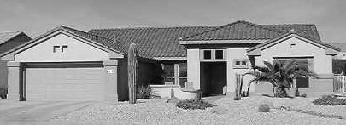
Lynn Verheul
623/221-5171

Similar Plan: Verano, *Catalina
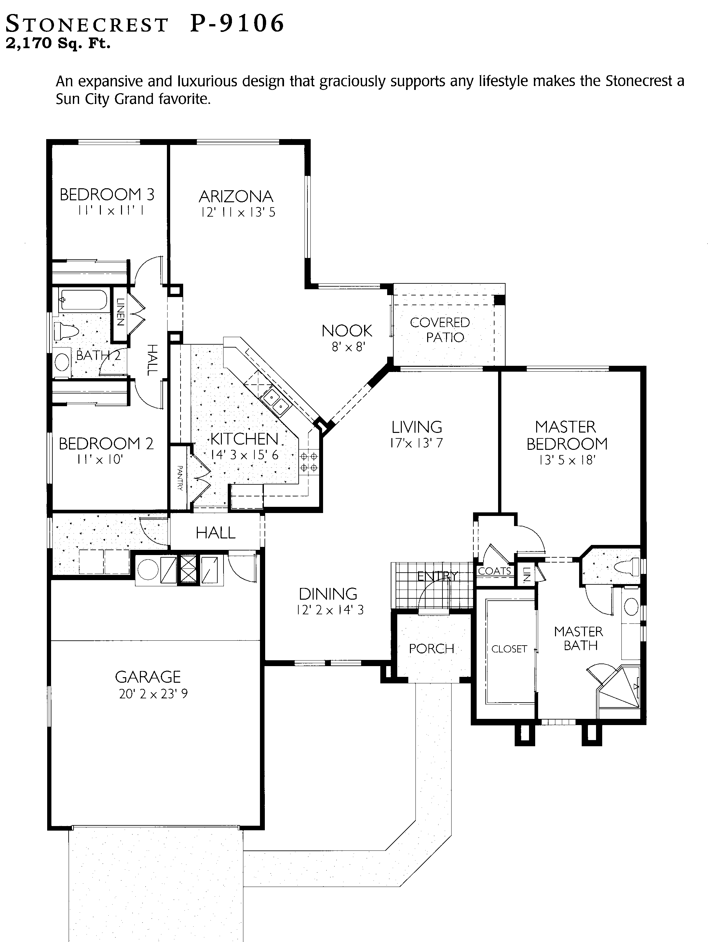
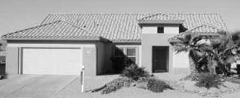
Lynn Verheul
623/221-5171

Similar Floor Plan: Hacienda & *Lakeside
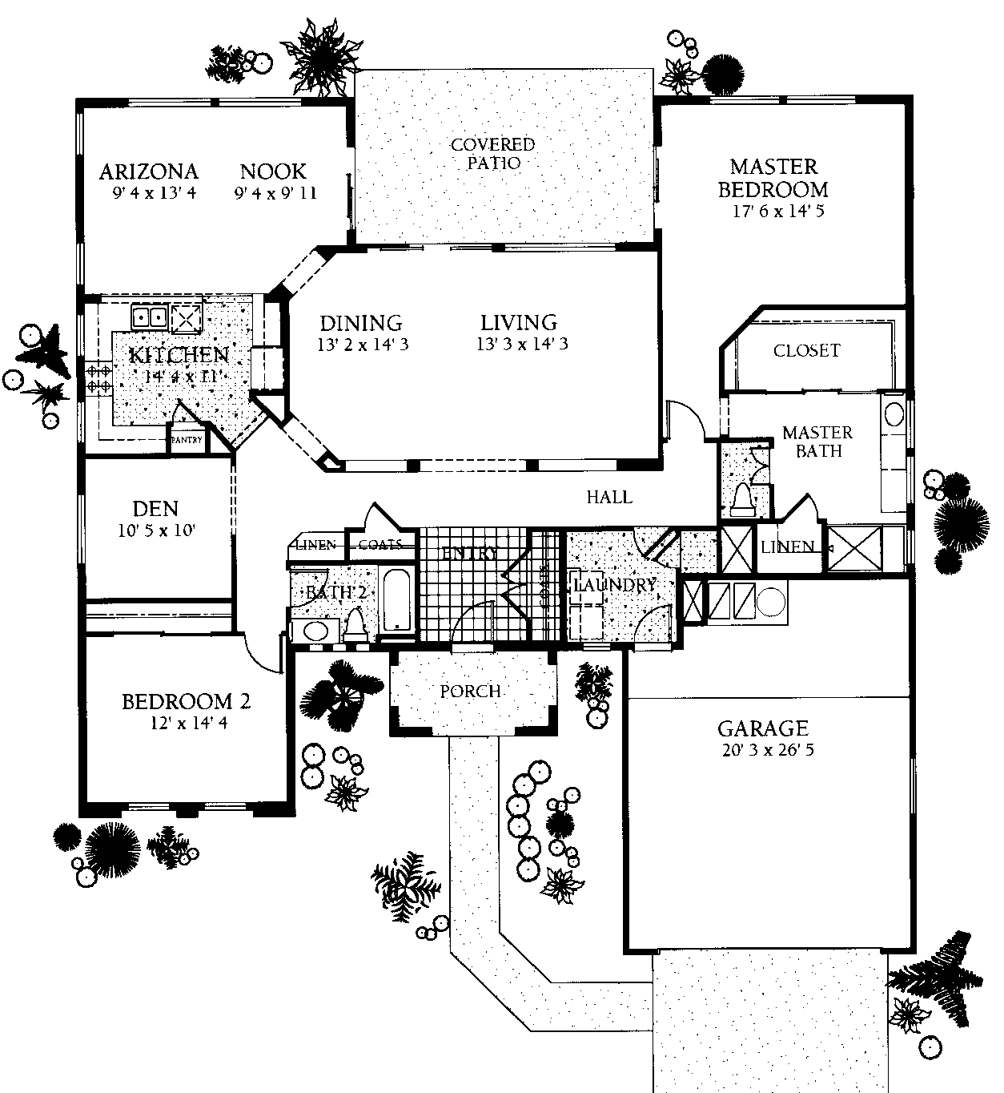
Windrose P9107
2,259 Sq. Ft.
Similar Plan: *Sedona
Lynn Verheul
623/221-5171

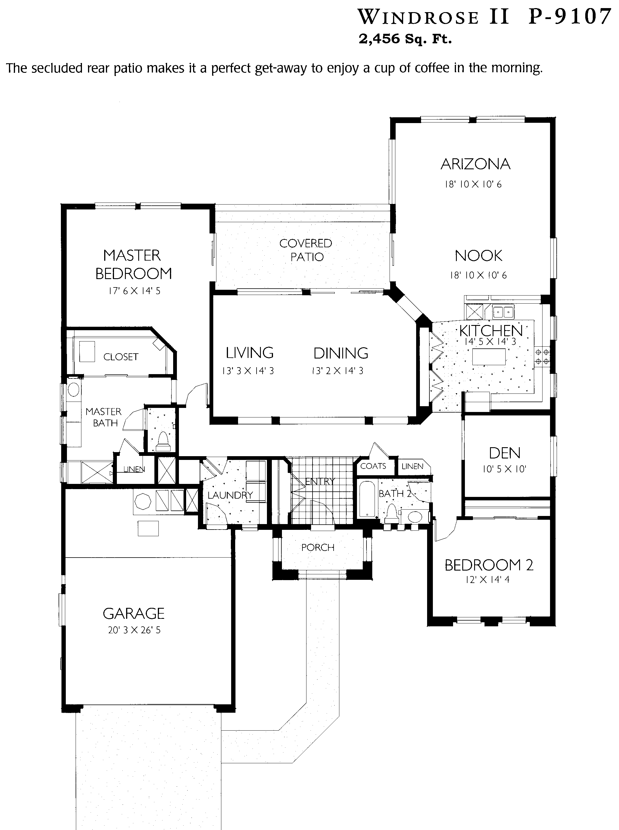
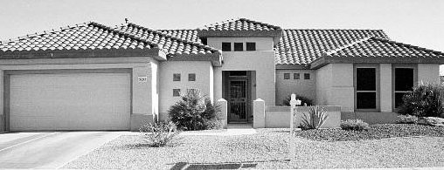
Lynn Verheul
623/221-5171

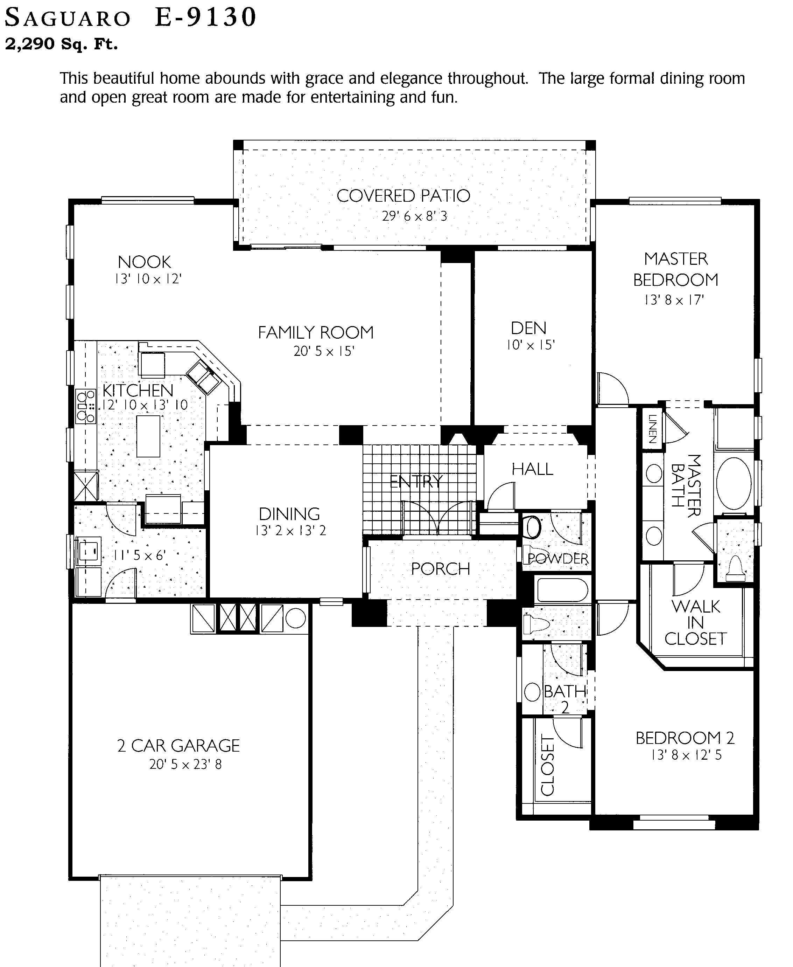
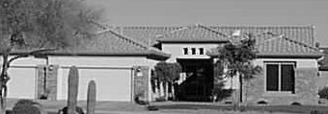
Lynn Verheul
623/221-5171

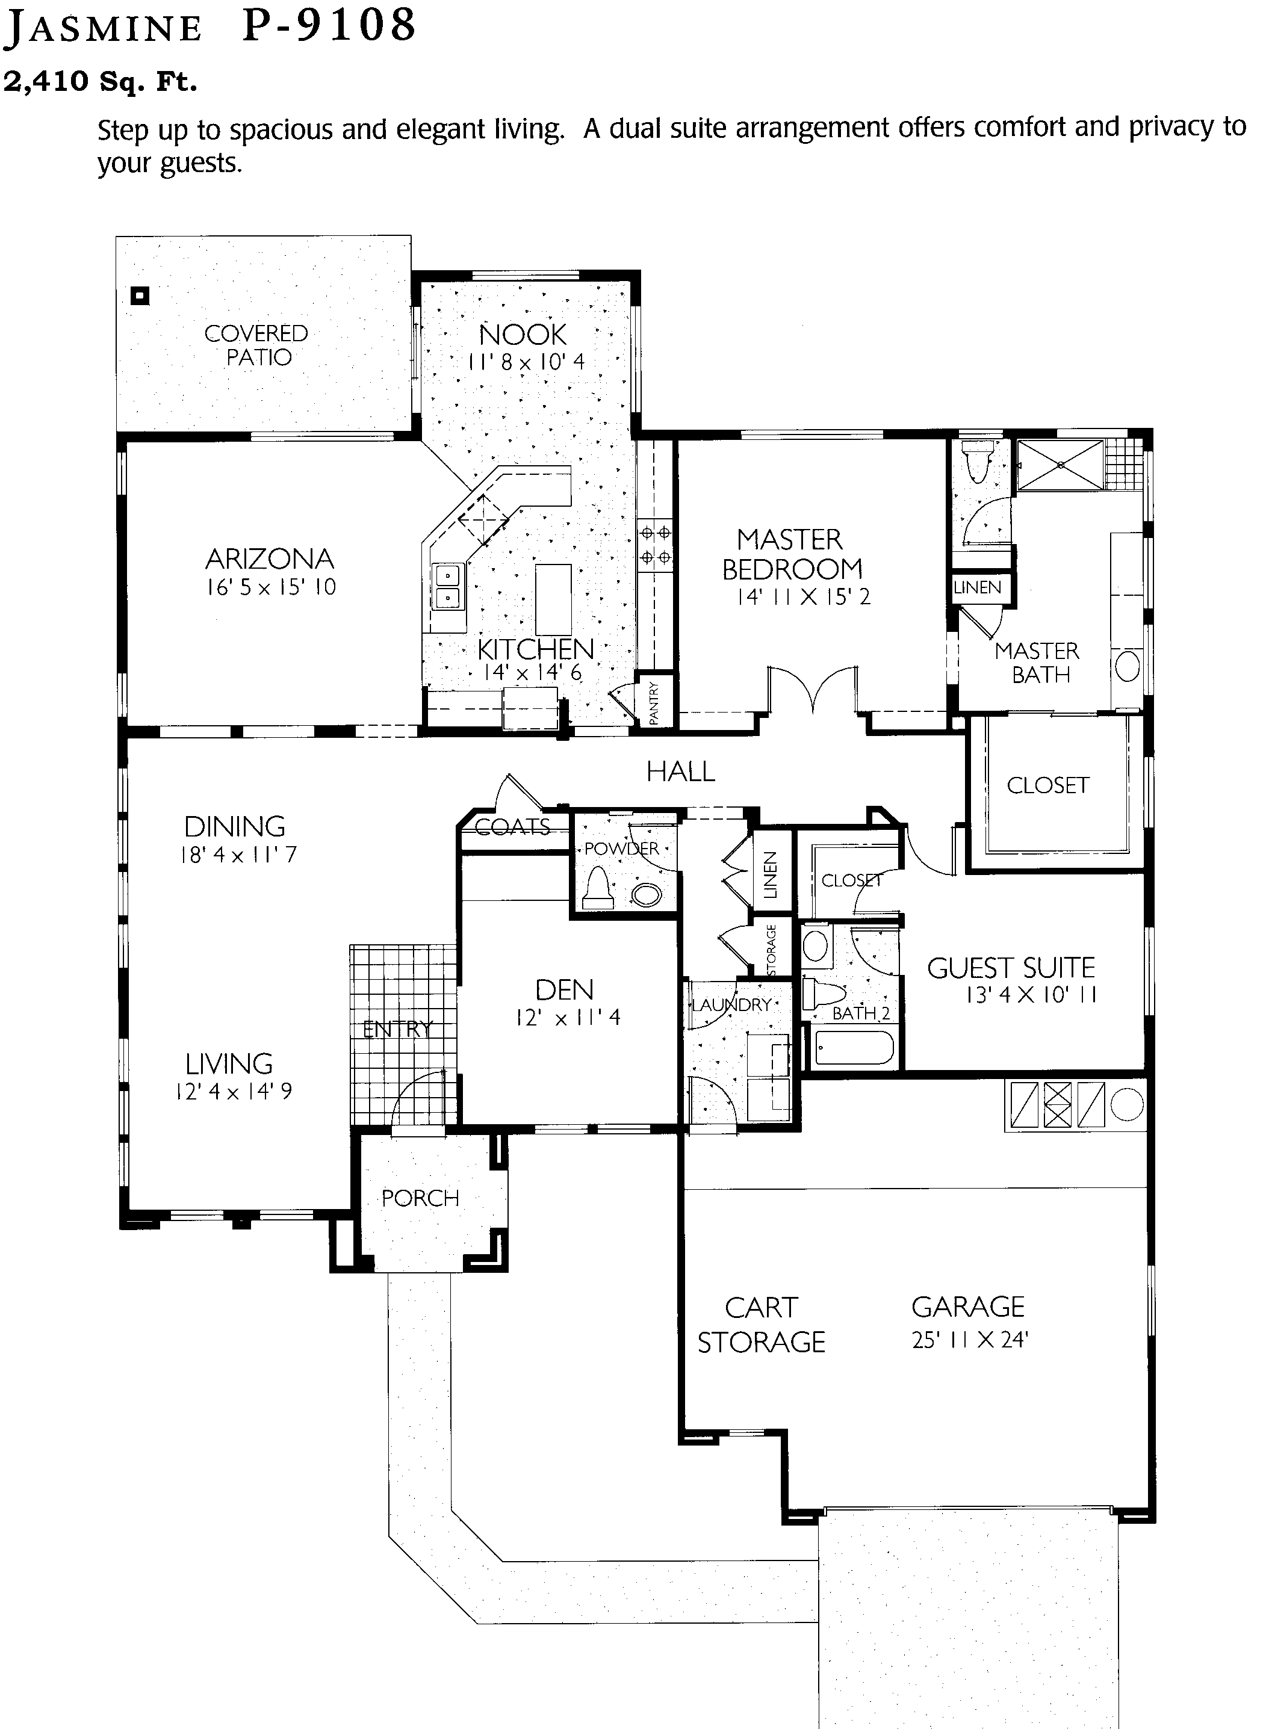
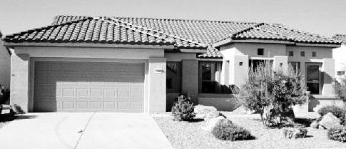
Lynn Verheul
623/221-5171

Similar Plan: *San Carlos
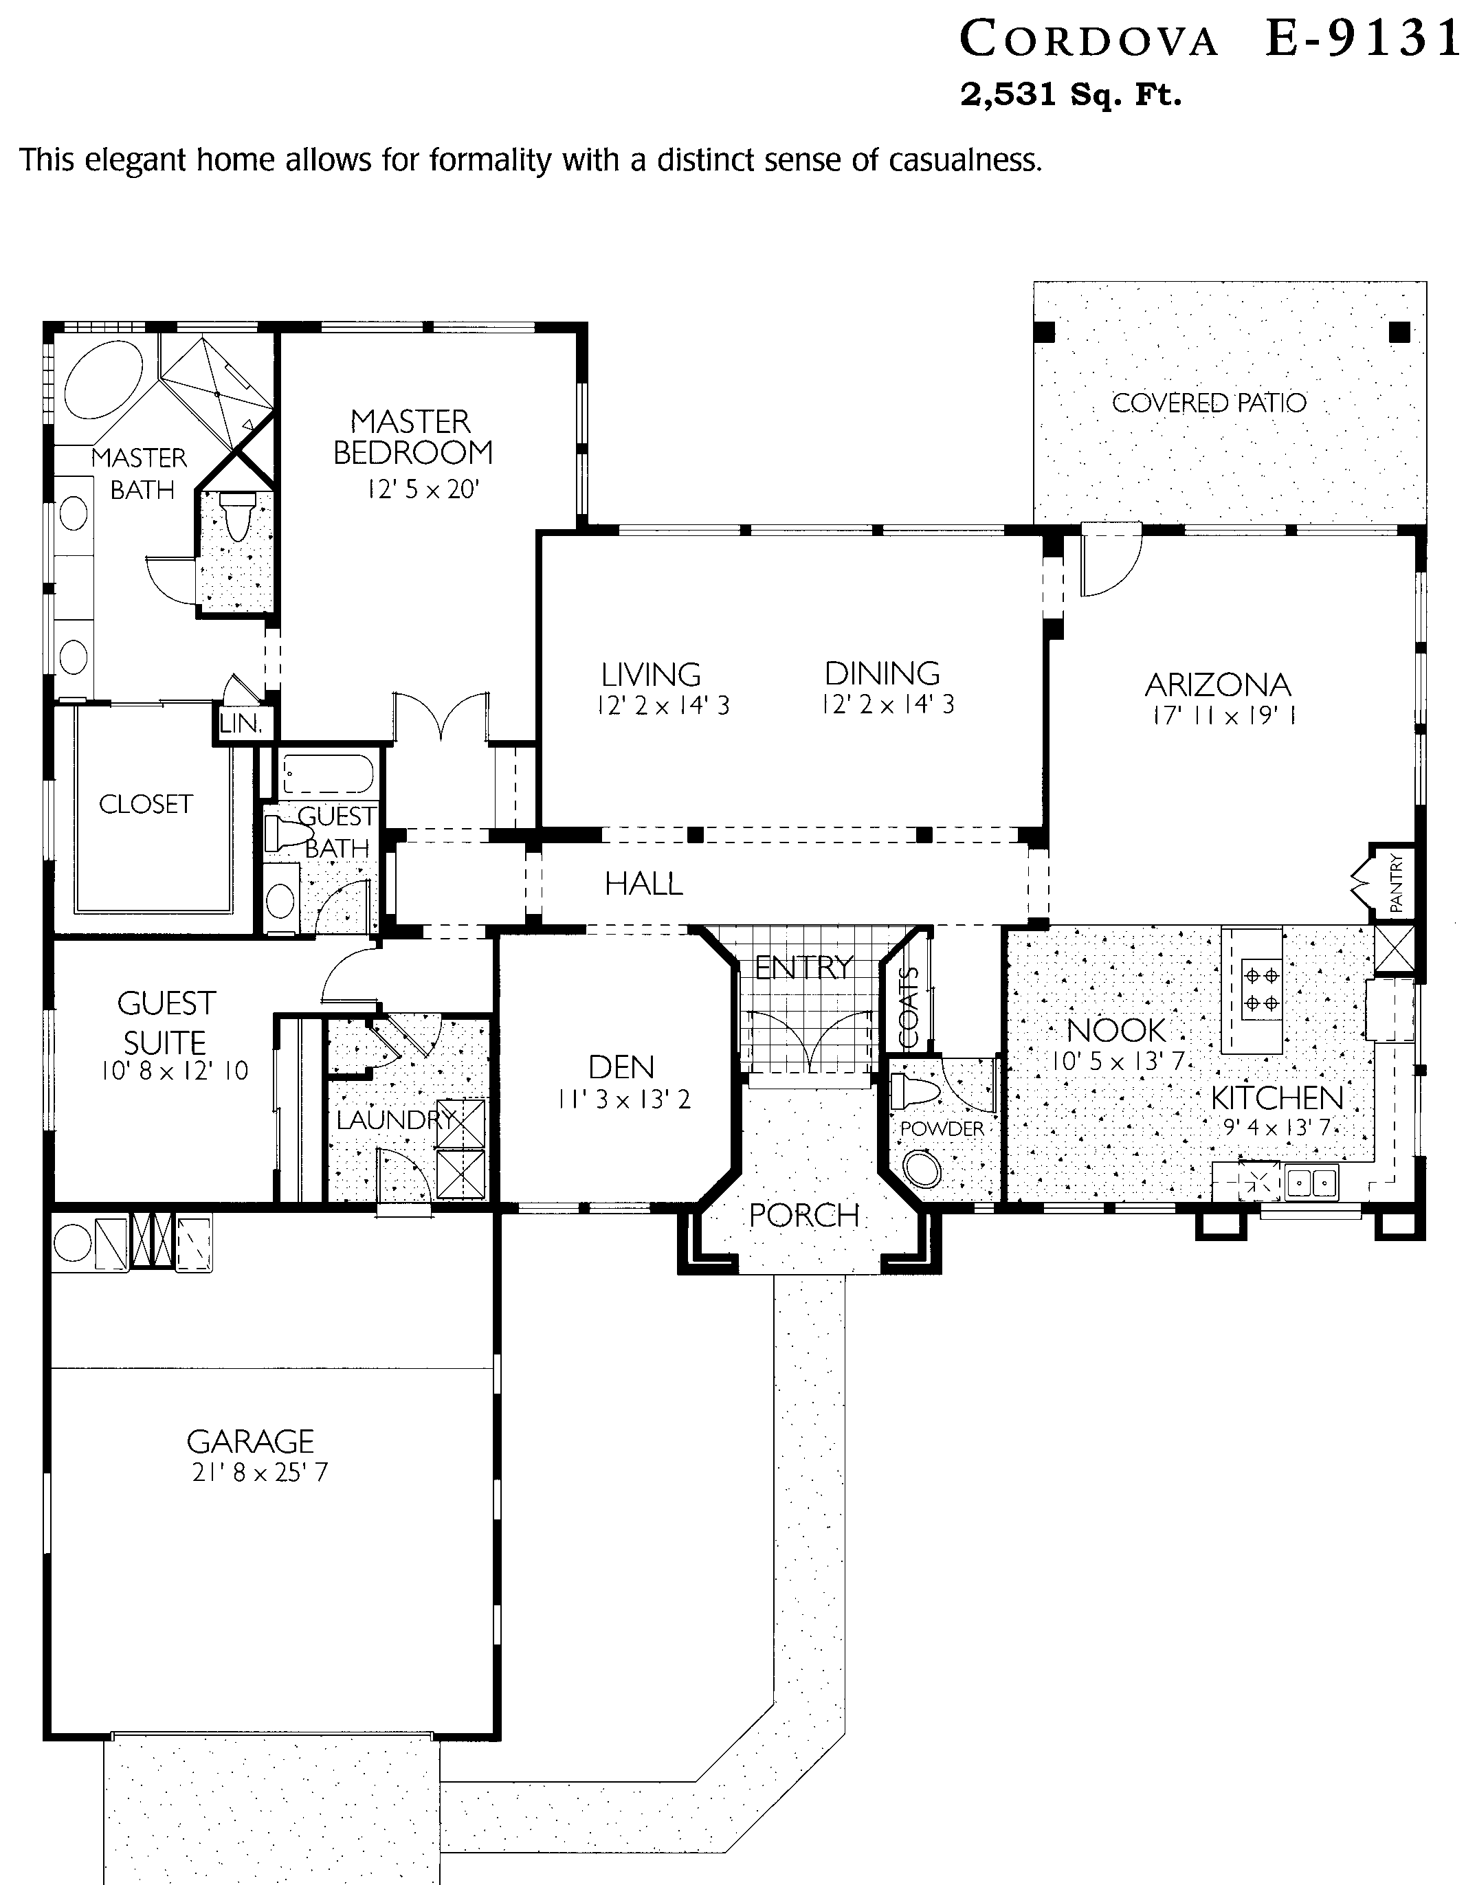
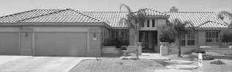
Lynn Verheul
623/221-5171

Similar Plan: *Somerton
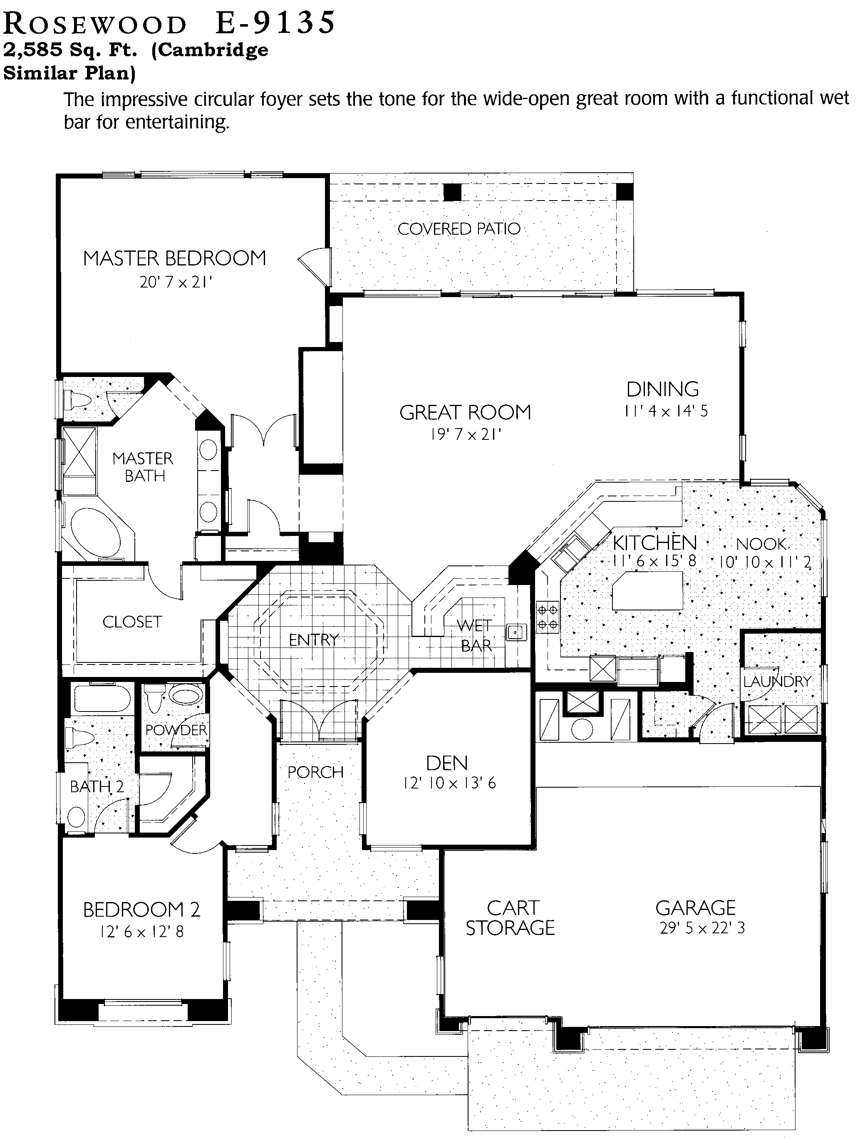
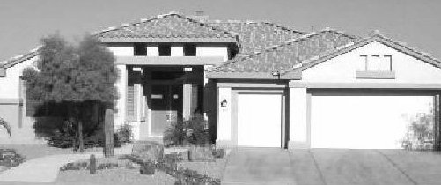
Lynn Verheul
623/221-5171

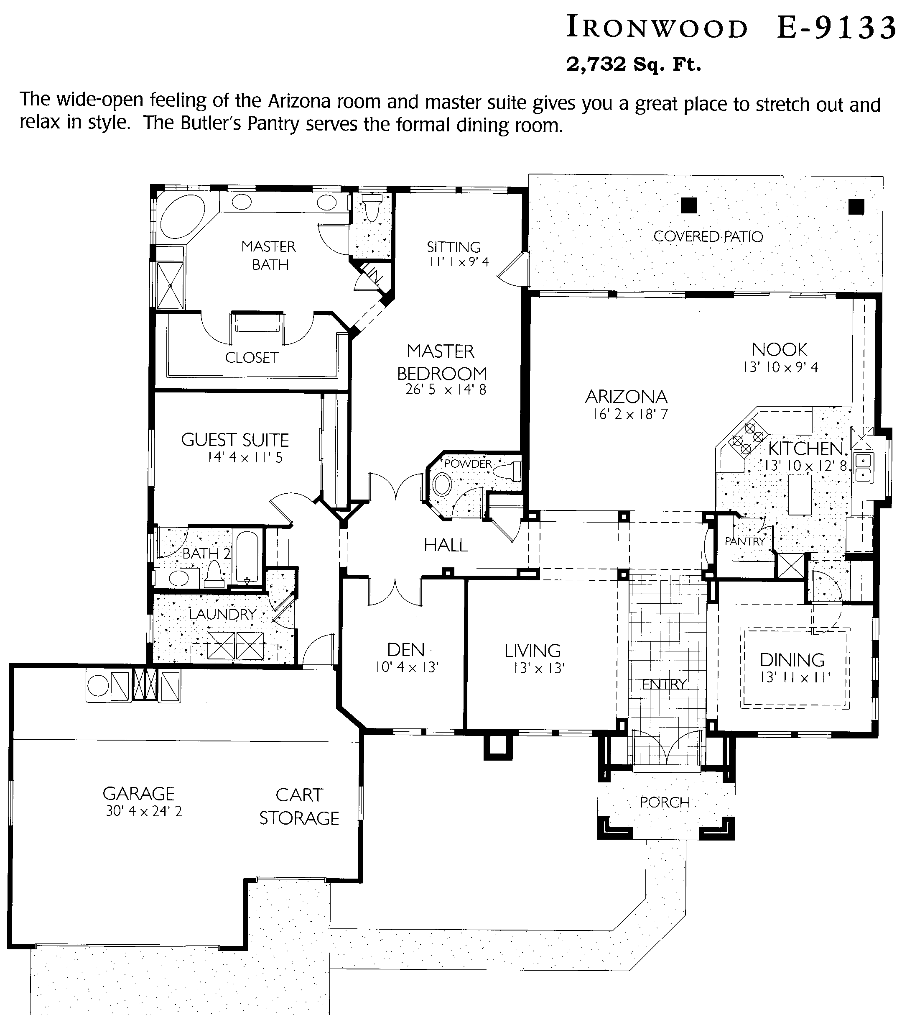
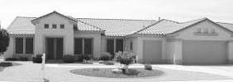
Lynn Verheul
623/221-5171

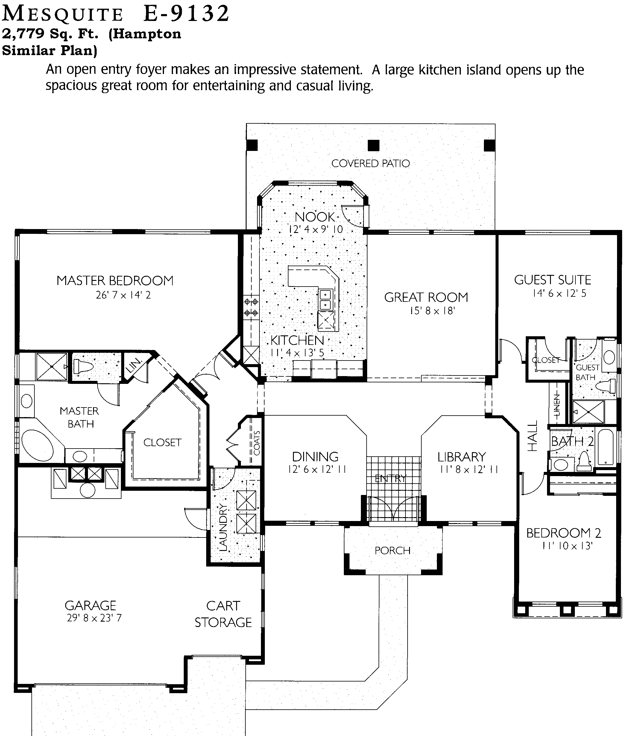
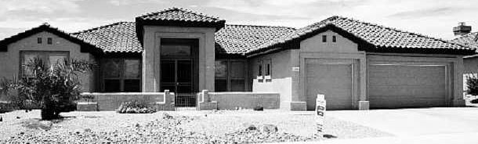
Lynn Verheul
623/221-5171

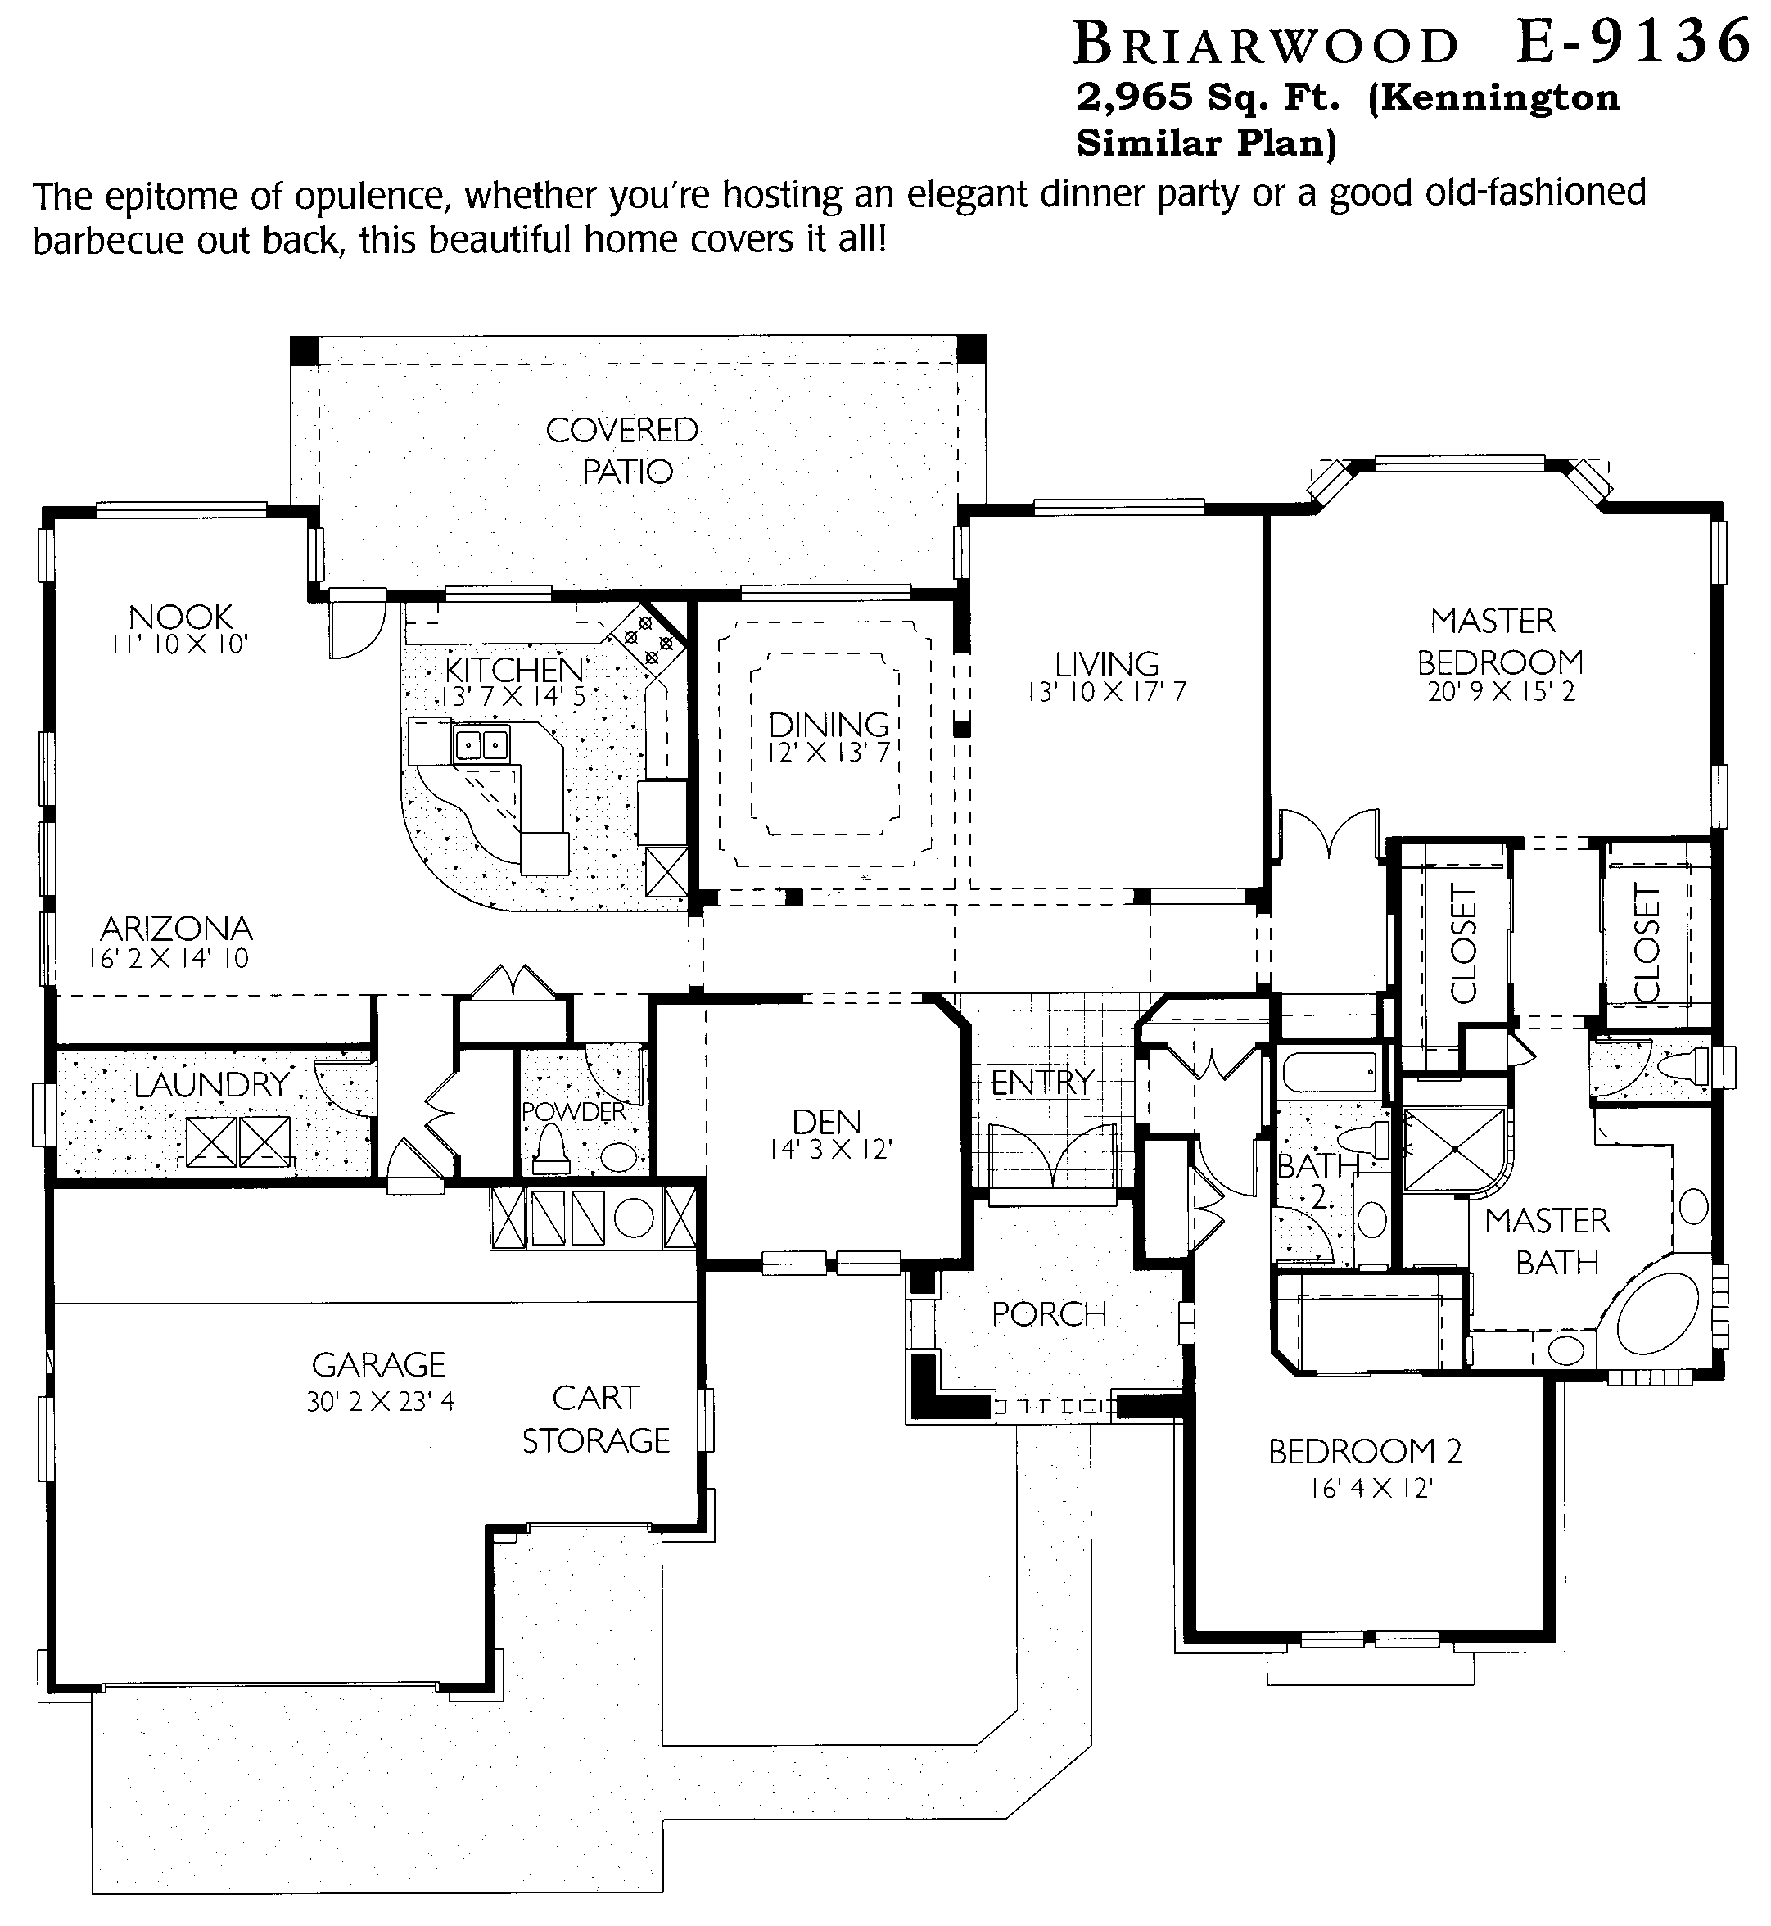
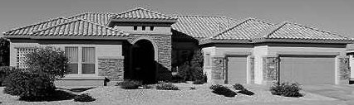
Lynn Verheul
623/221-5171

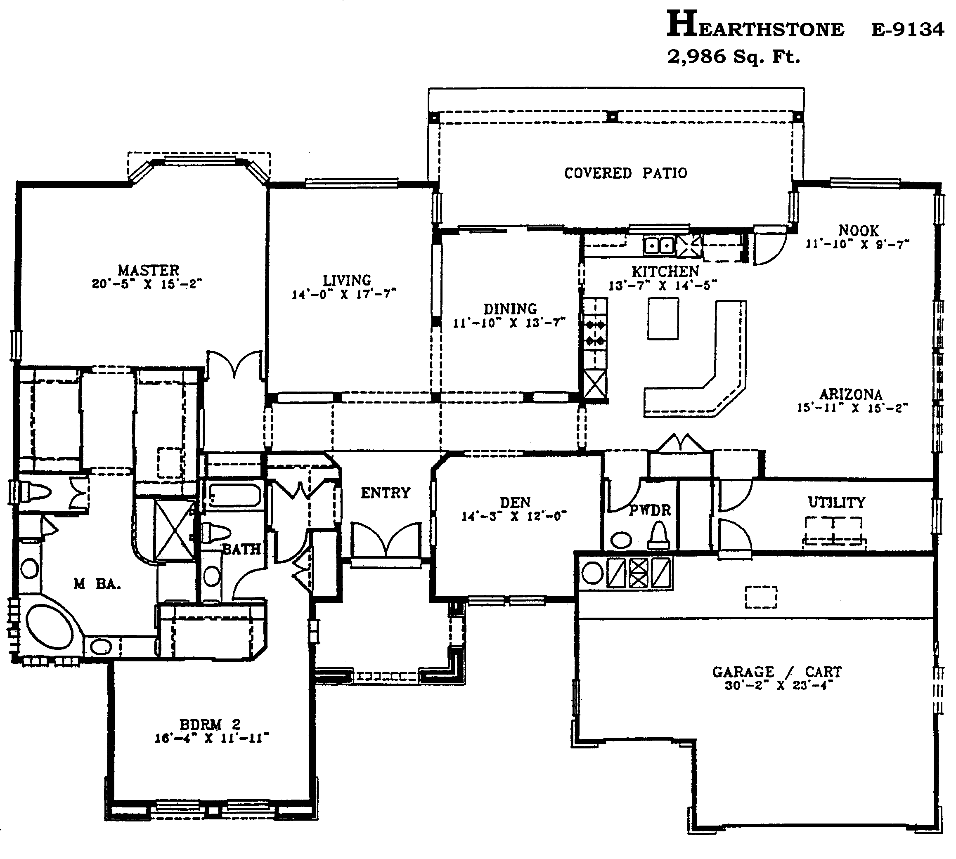
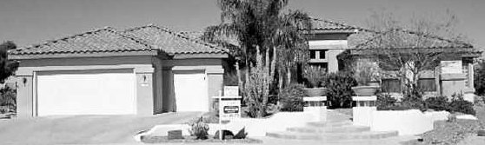
Lynn Verheul
623/221-5171

Similar Plan: *Scottsdale
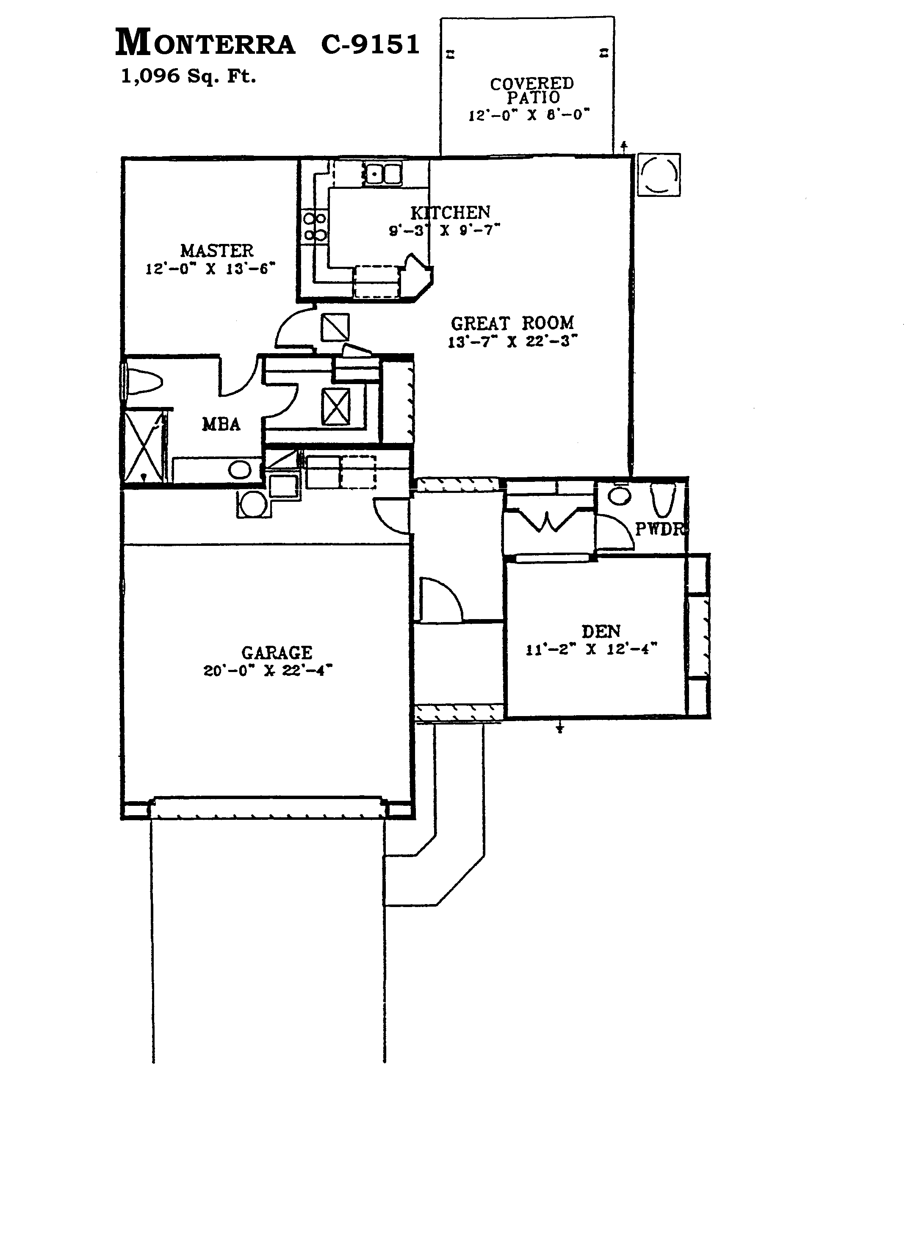
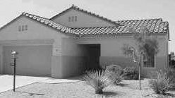
Lynn Verheul
623/221-5171

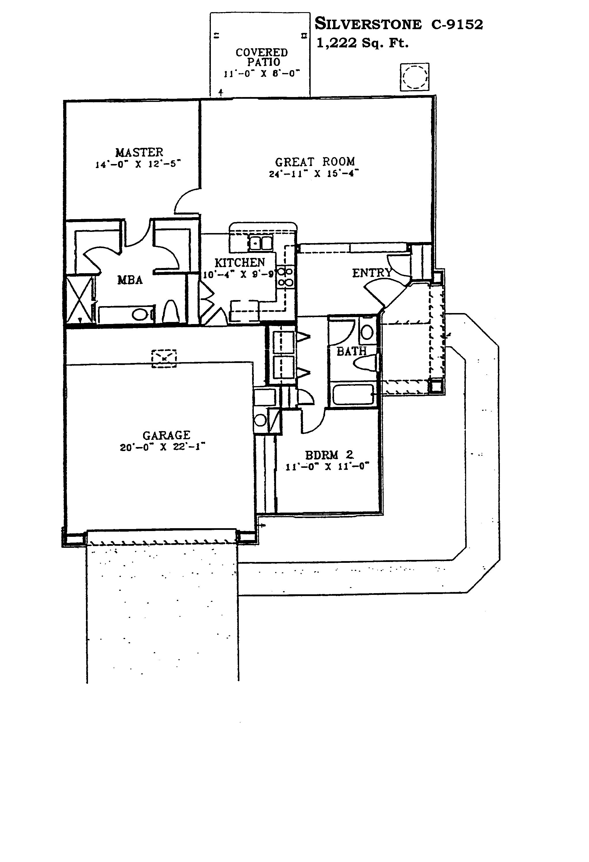
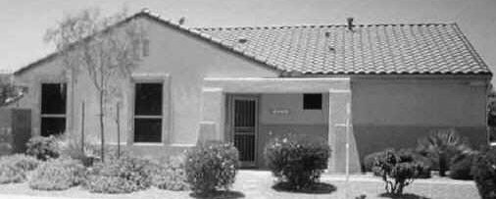
Lynn Verheul
623/221-5171

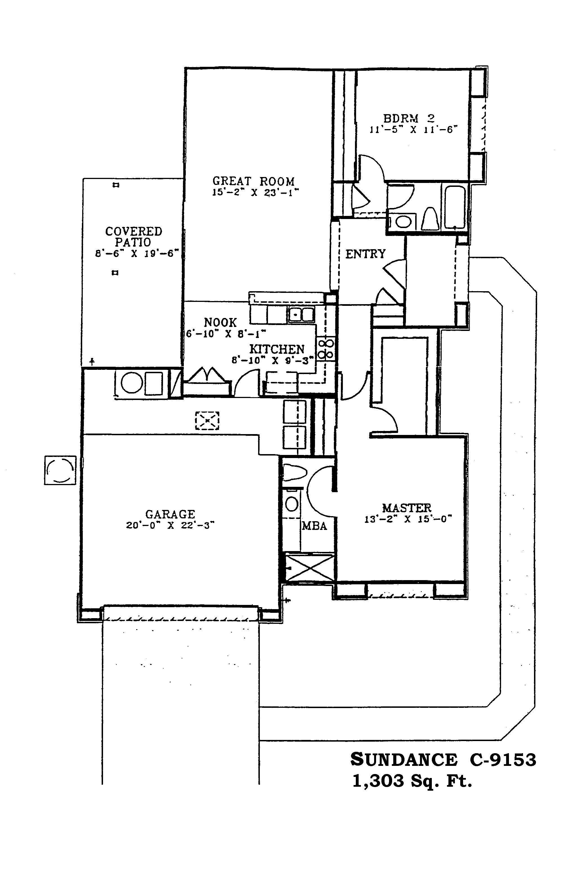
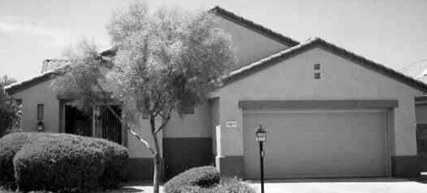
Lynn Verheul
623/221-5171

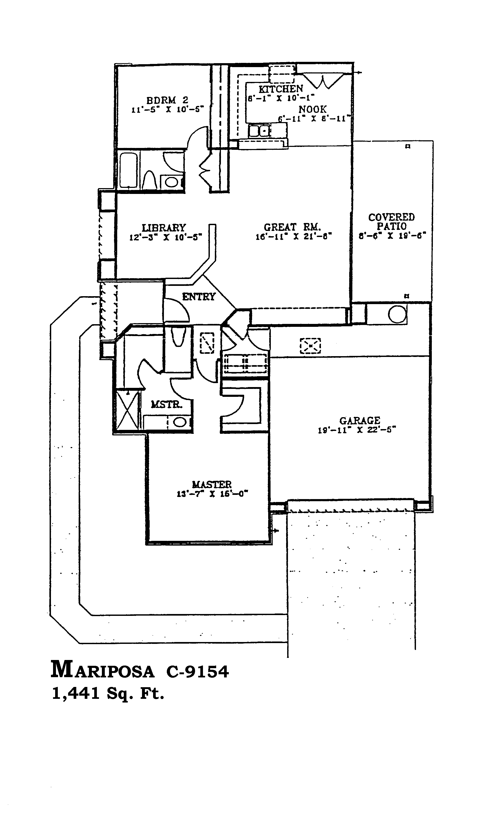
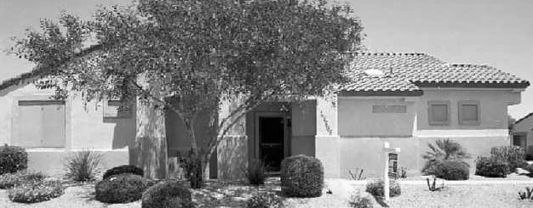
Lynn Verheul
623/221-5171

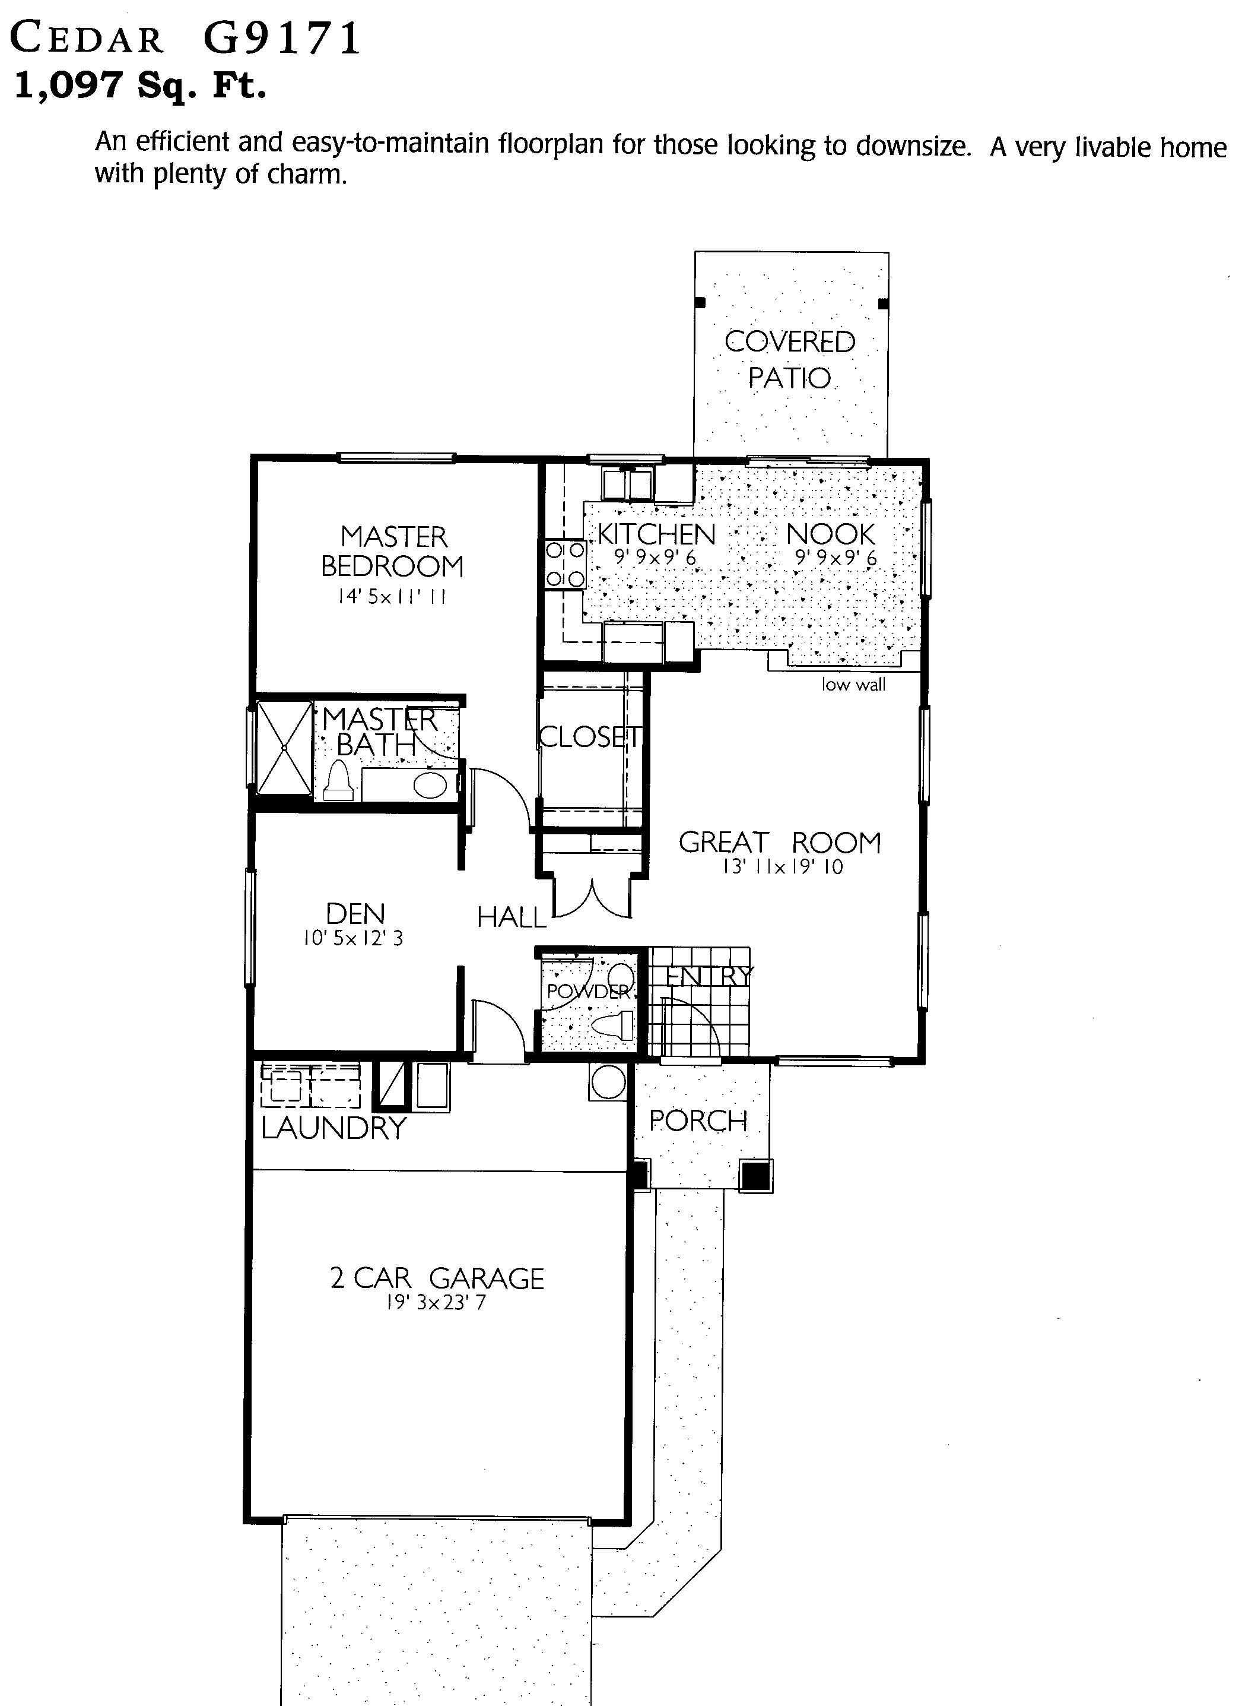
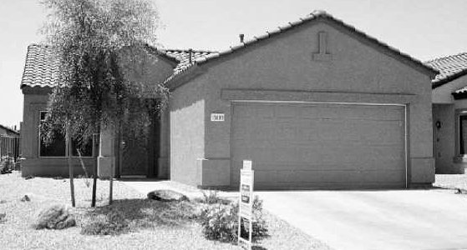
Lynn Verheul
623/221-5171

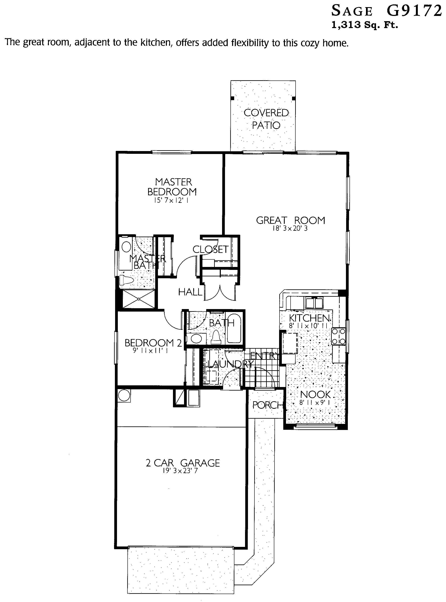
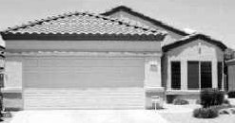
Lynn Verheul
623/221-5171

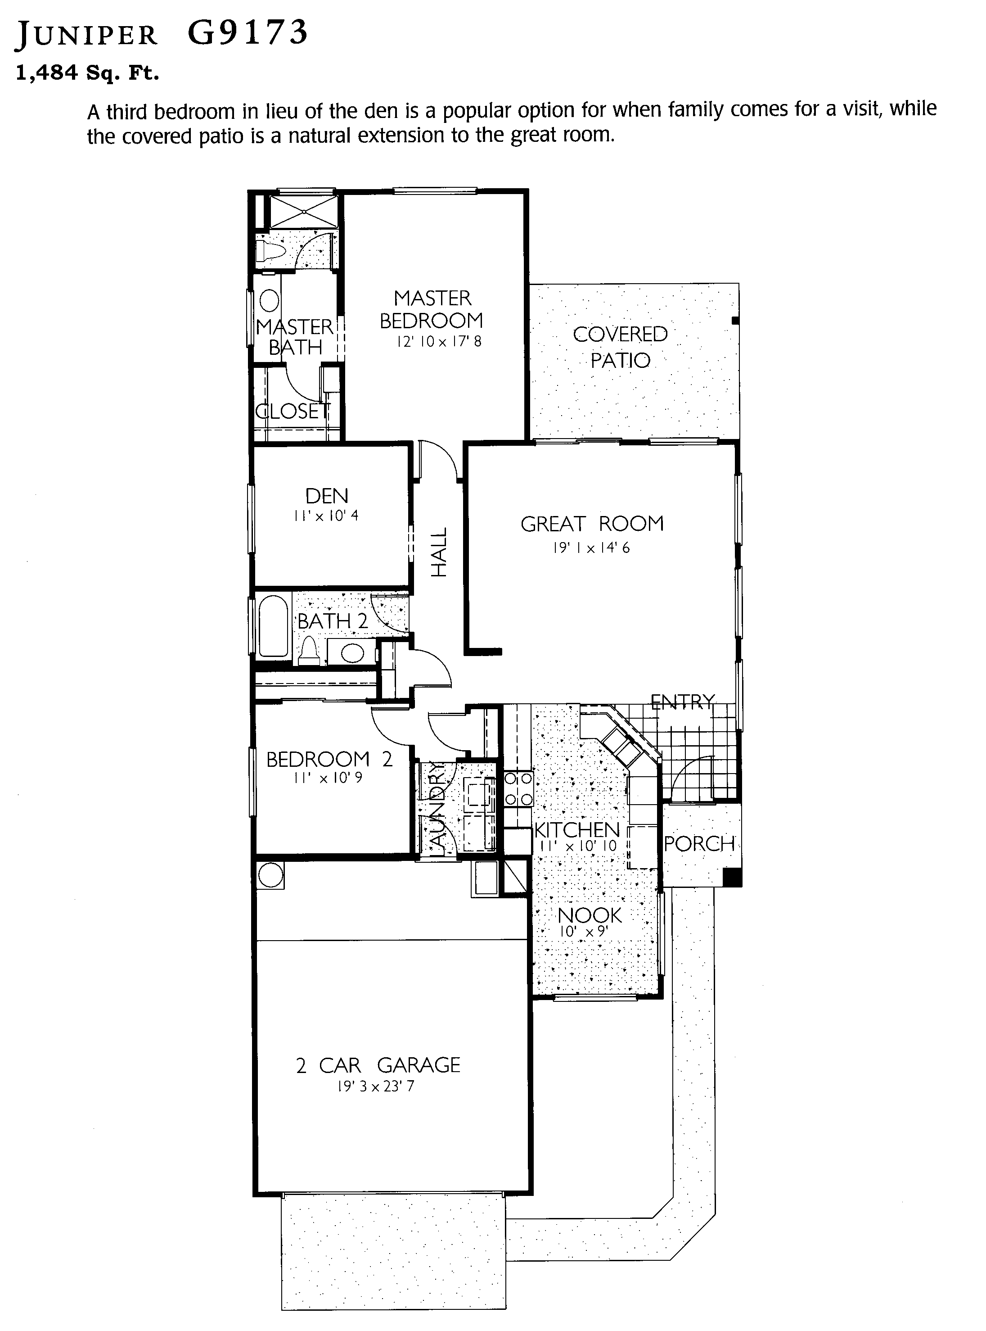
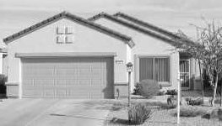
Lynn Verheul
623/221-5171

Sun City Grand
92Series: 2001-Present

Similar
Model Name Sq. Ft. Models
S9210 Iris 1,120
S9211 Cypress 1,246 Willow
S9212 Cactus Flower 1,409
S9213 Azalea 1,482
S9214 Sycamore 1,688 Madera
S9215 Desert Rose 1,814 Verde
P9231 Borgata 1,852 Palo Verde & *Prescott
P9232 Valencia 1,920 Cholla & *Flagstaff
P9233 Sierra 1,997 Coronado
P9234 Verano 2,133 Verbena & *Catalina
P9235 Mission 2,260
P9236 Hacienda 2,314 Stonecrest & *Lakeside
E9251 Ashbury 2,439
E9252 Cambridge 2,627 Rosewood
E9253 Hampton 2,808 Mesquite
E9254 Kensington 2,988 Briarwood
E9255 Windsor 3,388

ASSOCIATION HOMES
C9221 Celebration 1,161
C9222 Legacy 1,284
C9223 Heritage 1,392 *Alpine
*SCW Plan

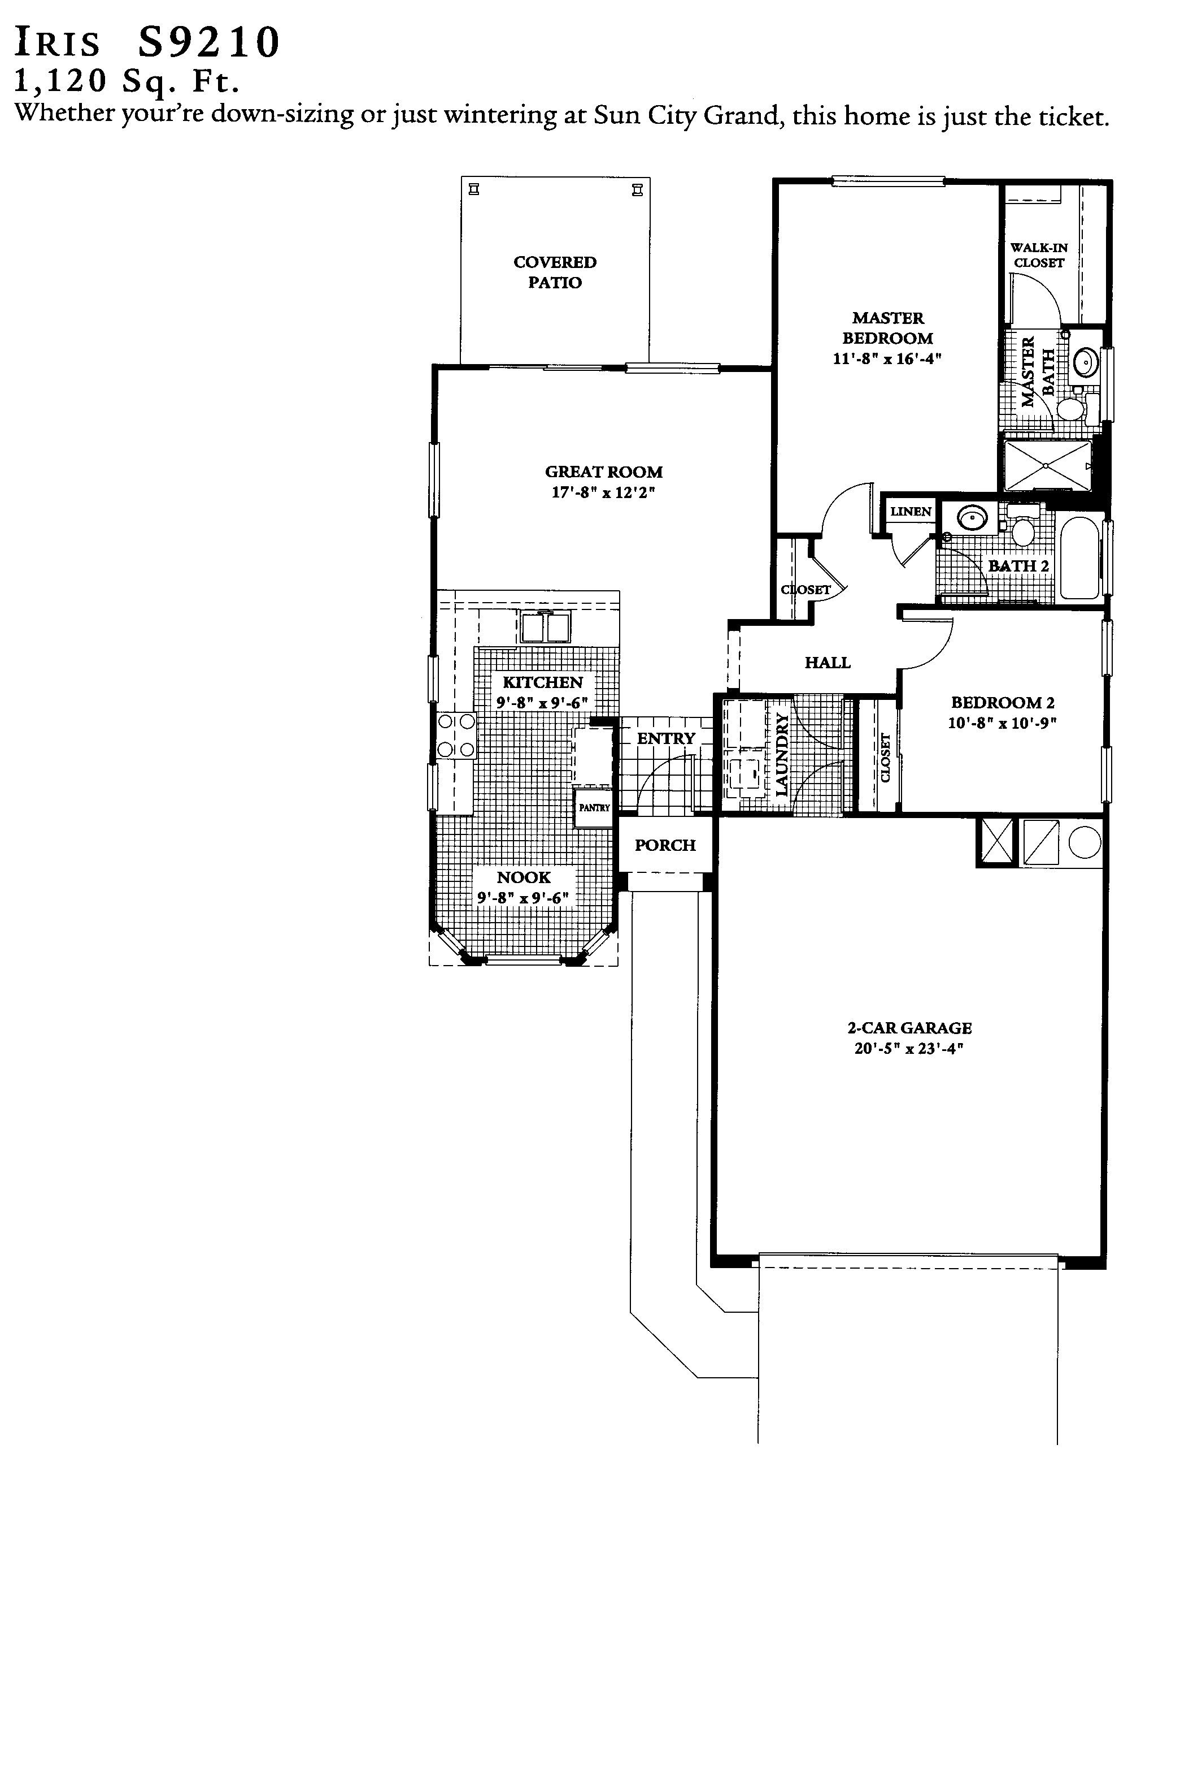
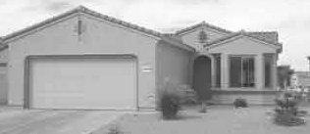
Lynn Verheul
623/221-5171

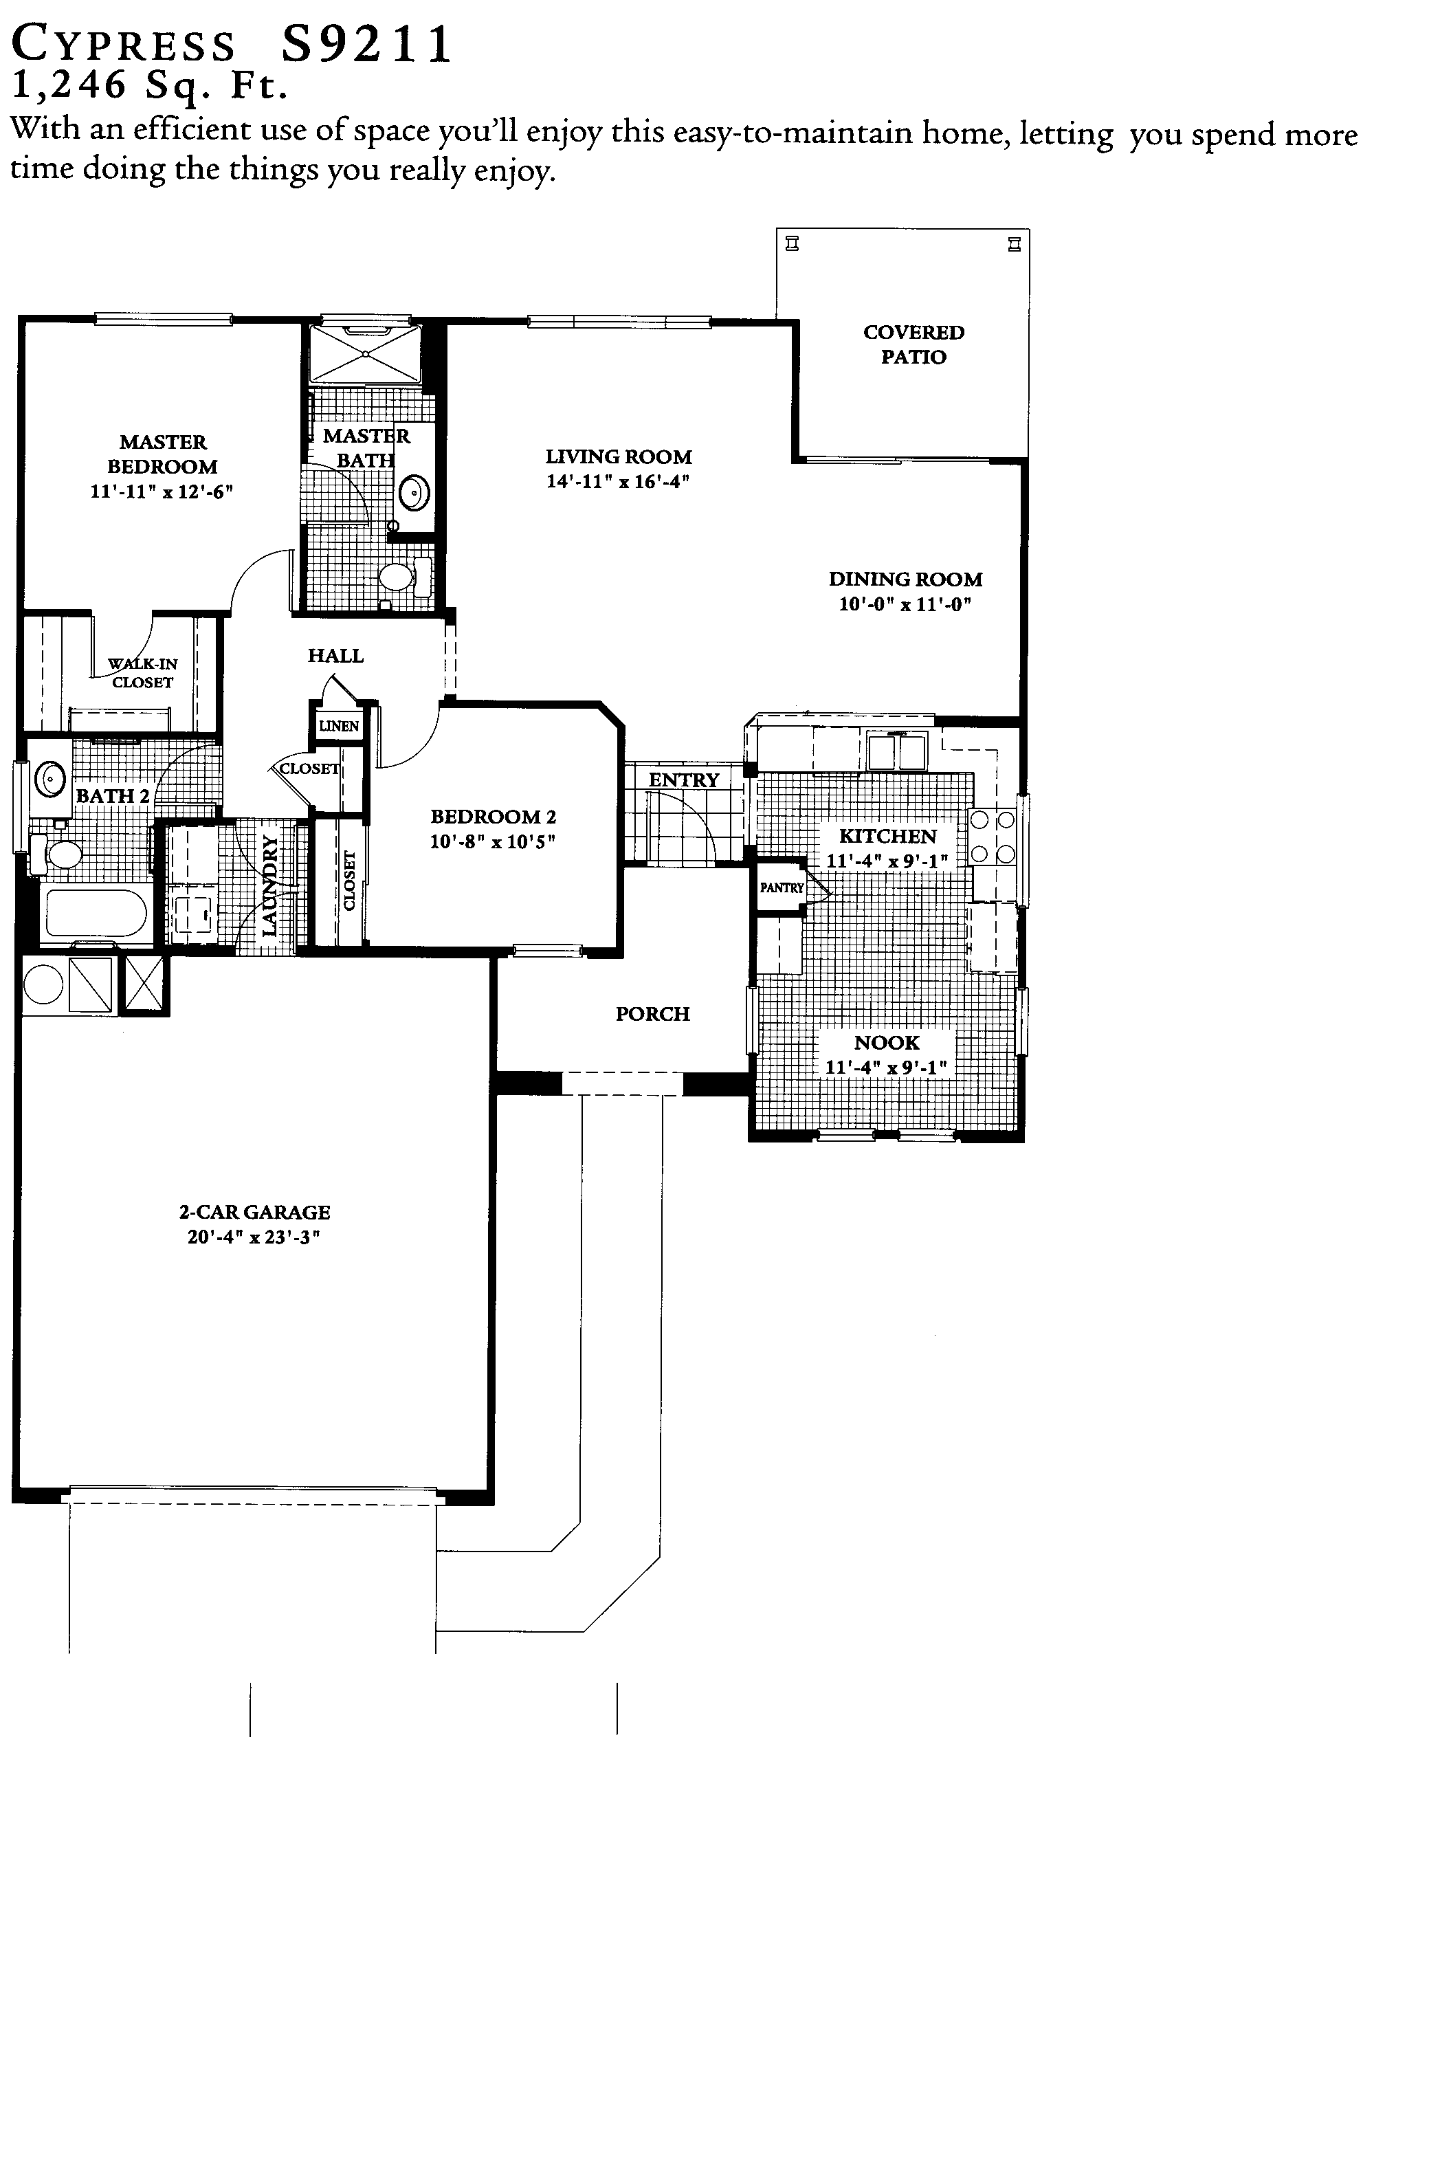
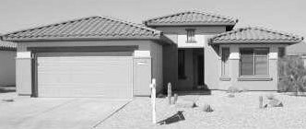
Lynn Verheul
623/221-5171

Similar Plan: Willow
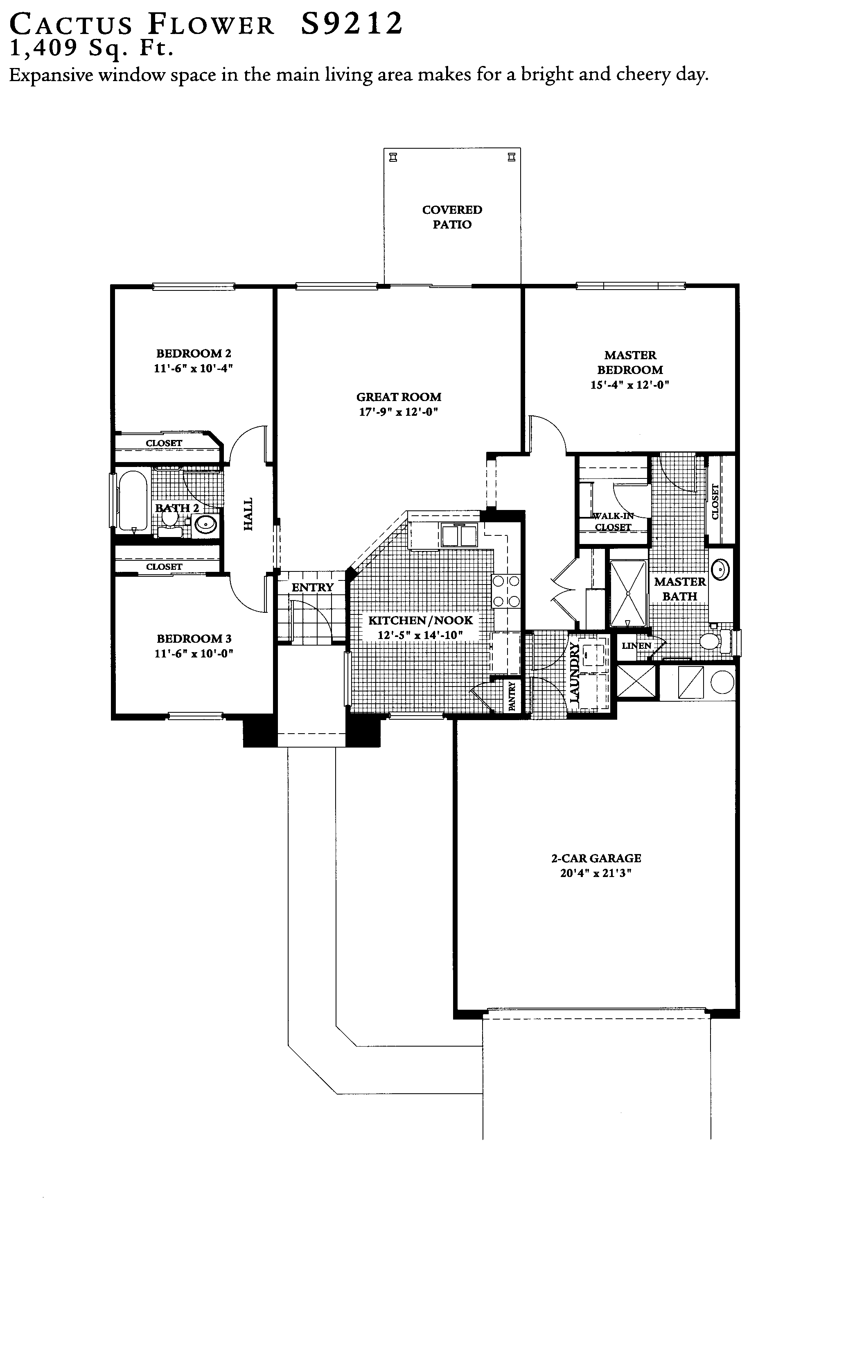
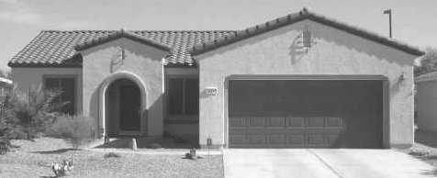
Lynn Verheul
623/221-5171

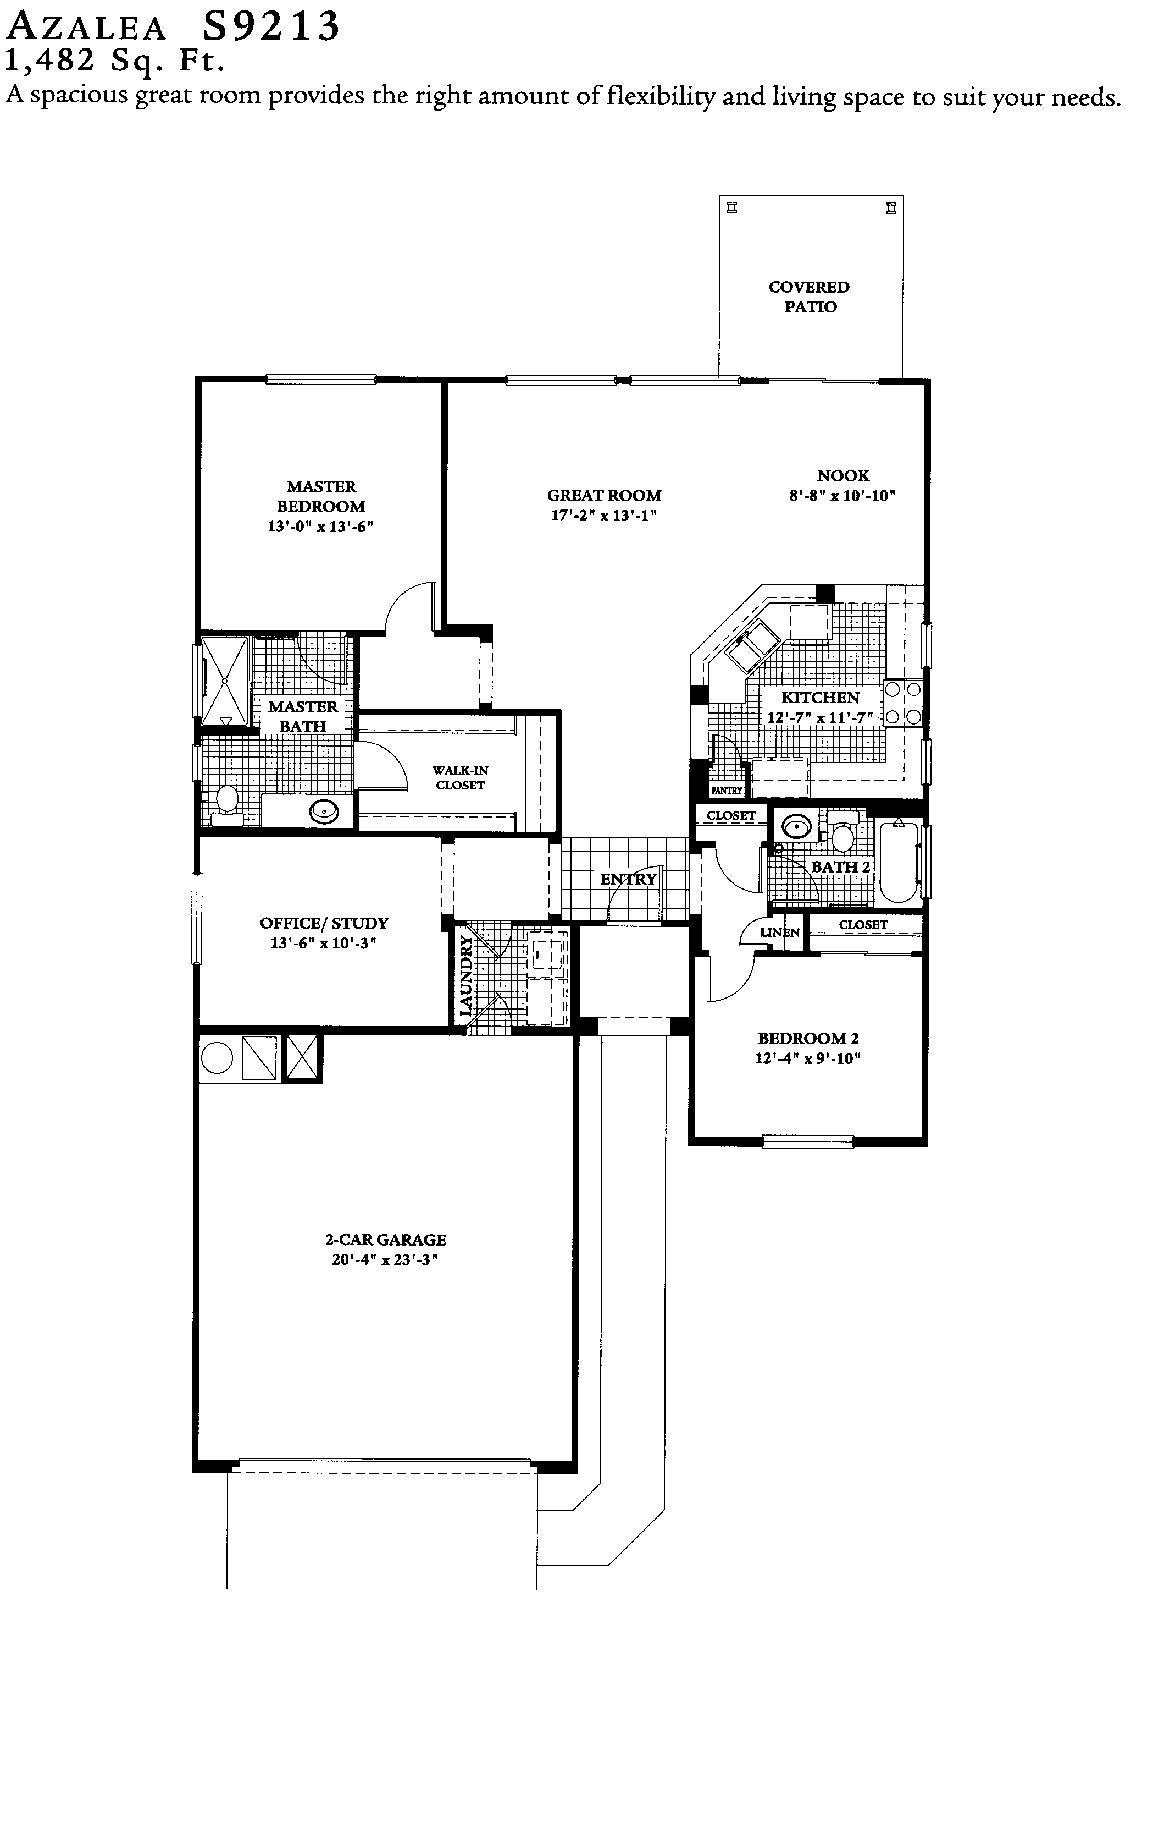
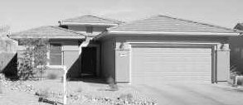
Lynn Verheul
623/221-5171

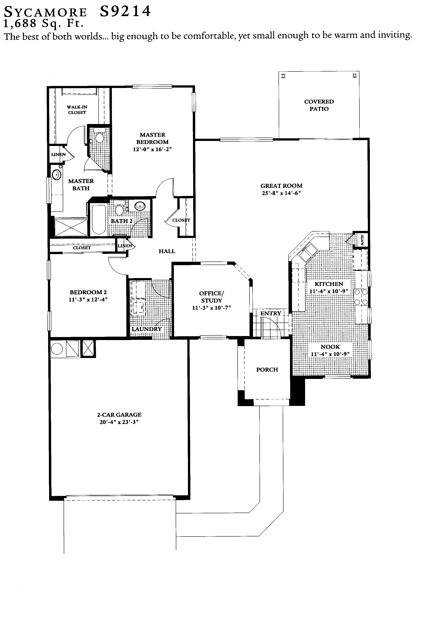
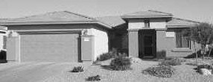
Lynn Verheul
623/221-5171

Similar Plan: Madera
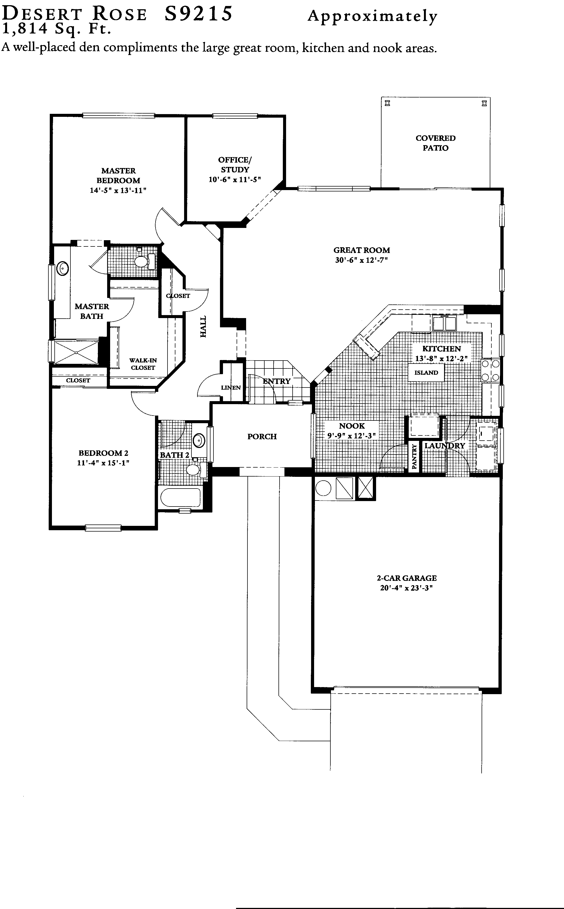
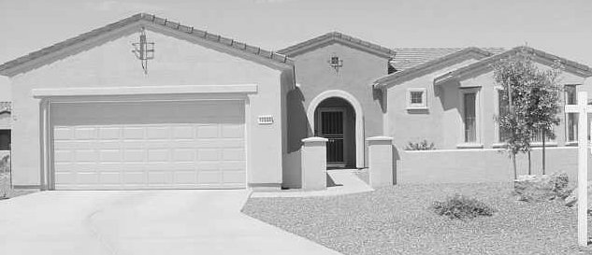
Lynn Verheul
623/221-5171

Similar Plan: Verde
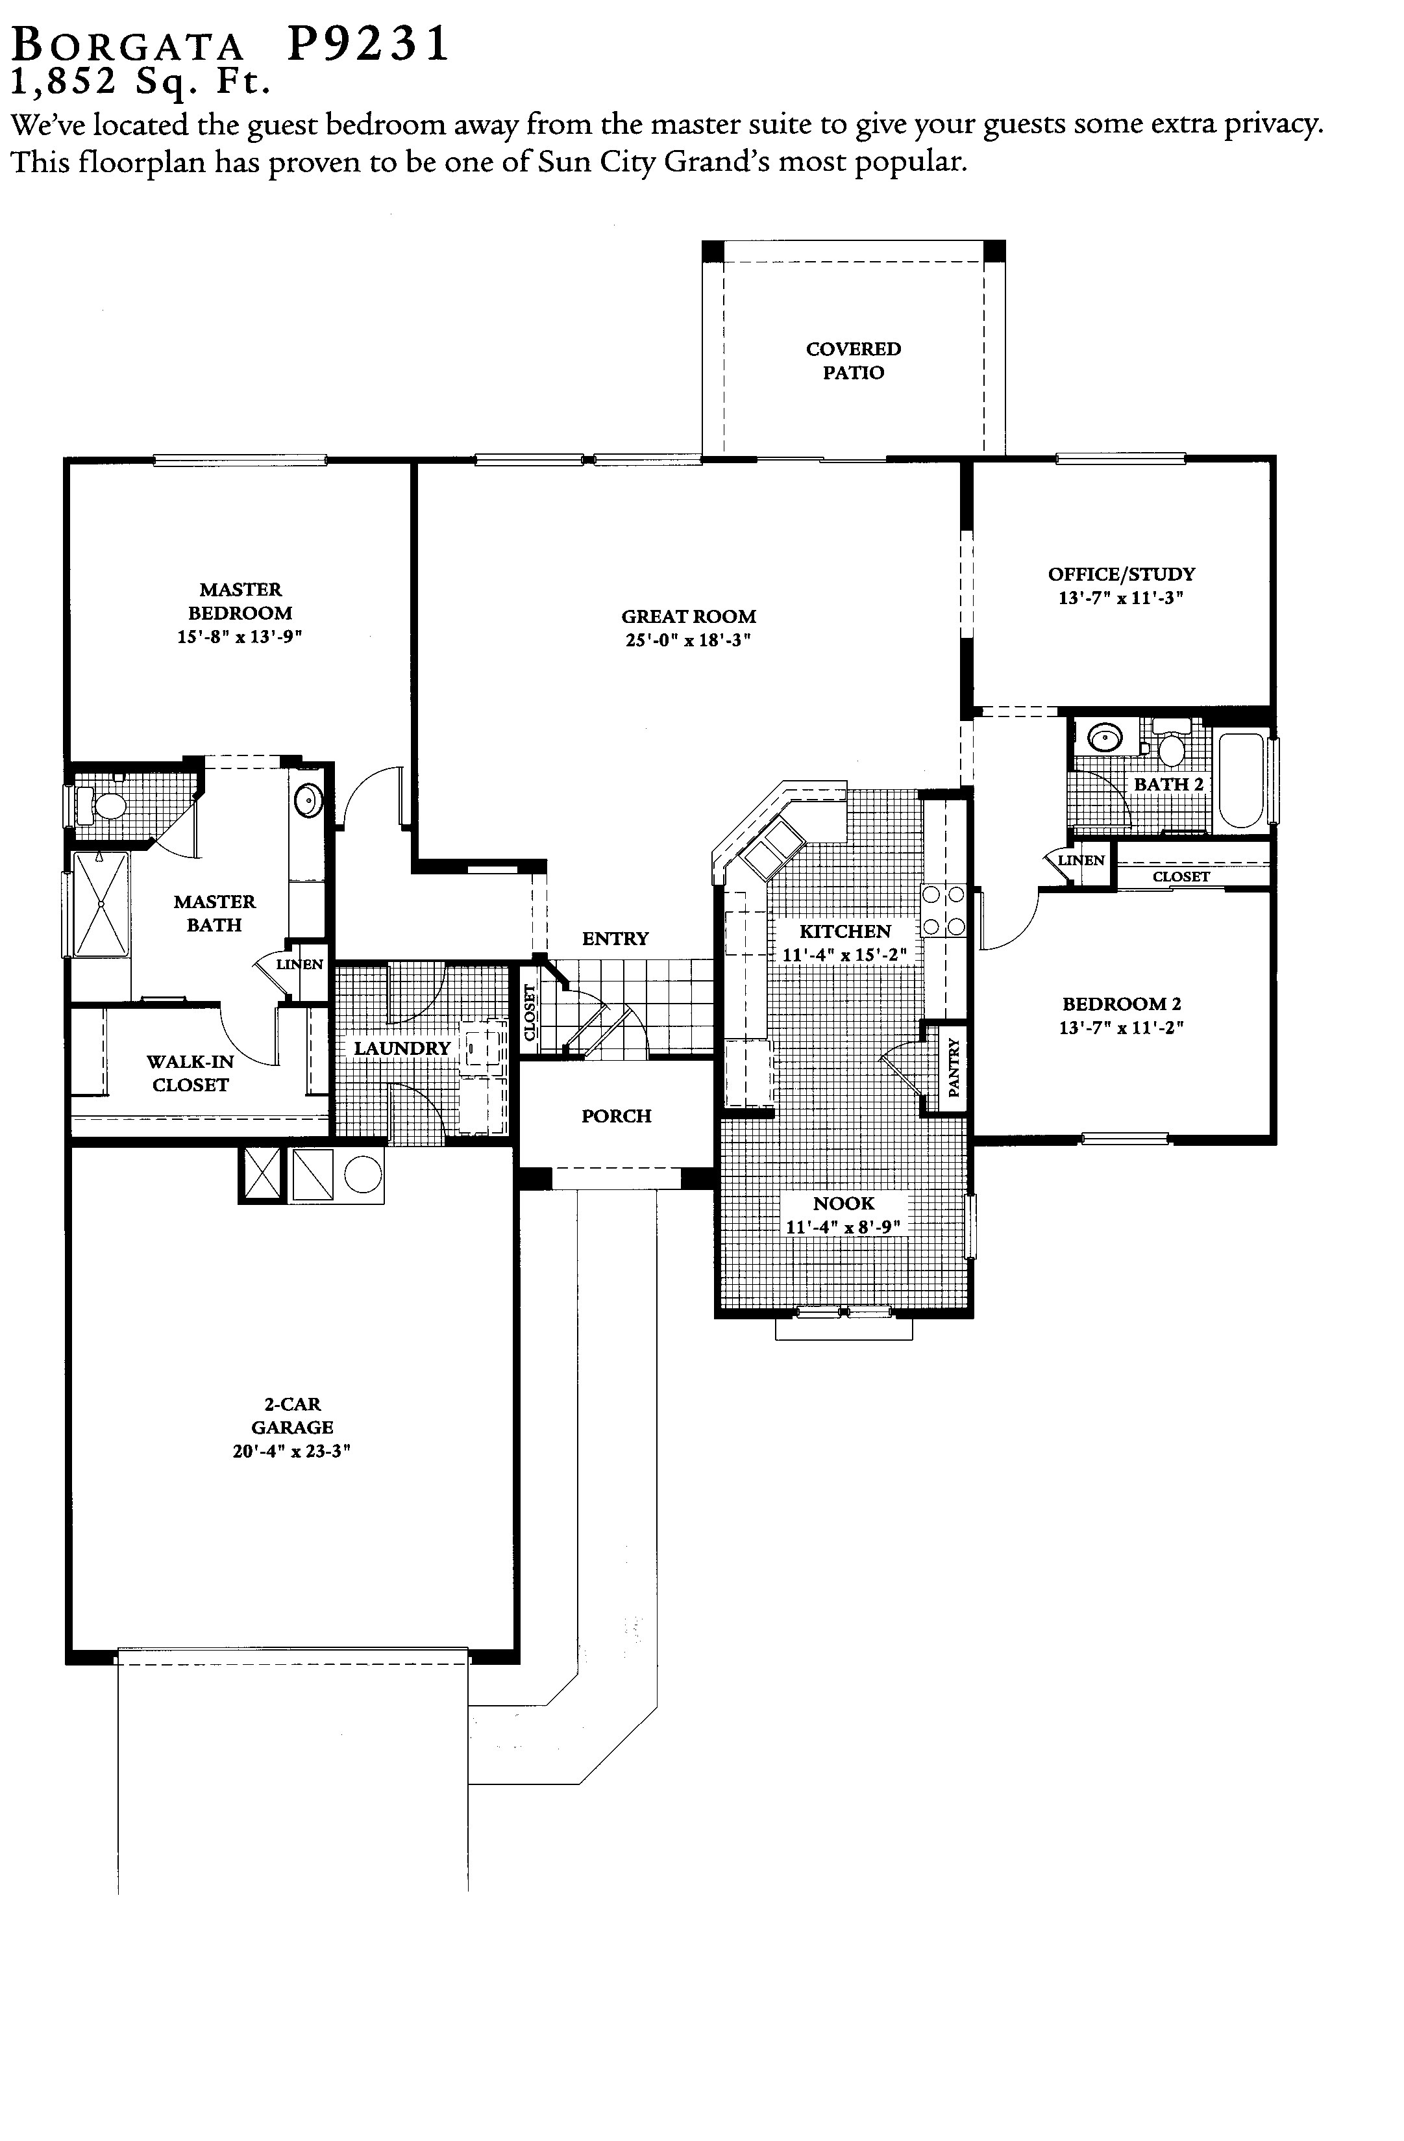
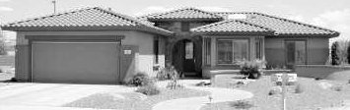
Lynn Verheul
623/221-5171

Similar Floor Plan: Palo Verde, *Prescott
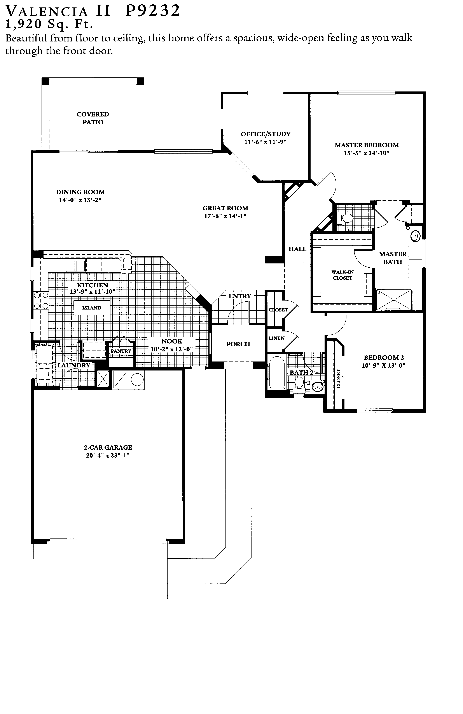
Lynn Verheul
623/221-5171

Similar Plan: Cholla, *Flagstaff
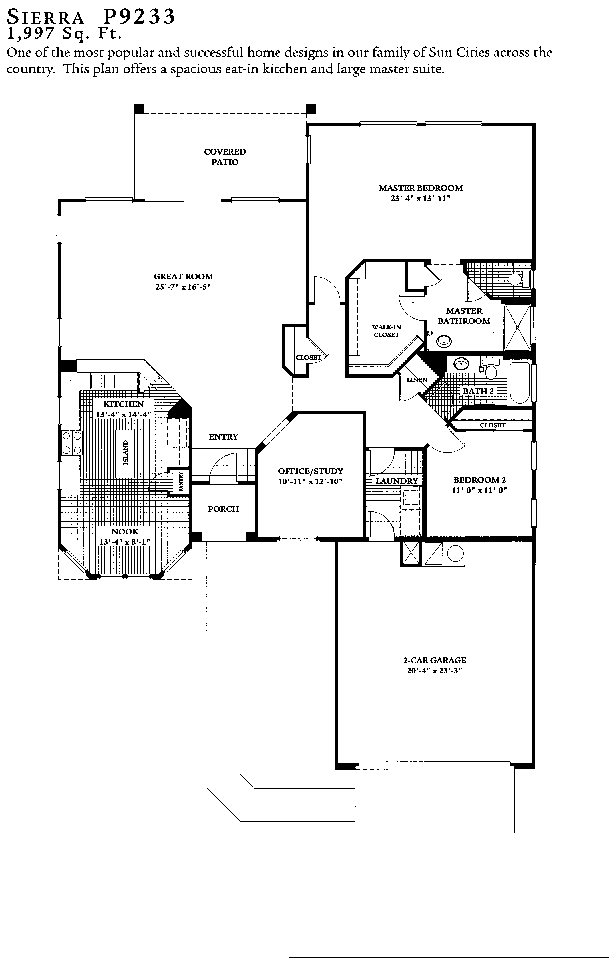
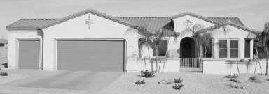
Lynn Verheul
623/221-5171

Similar Plan: Coronado
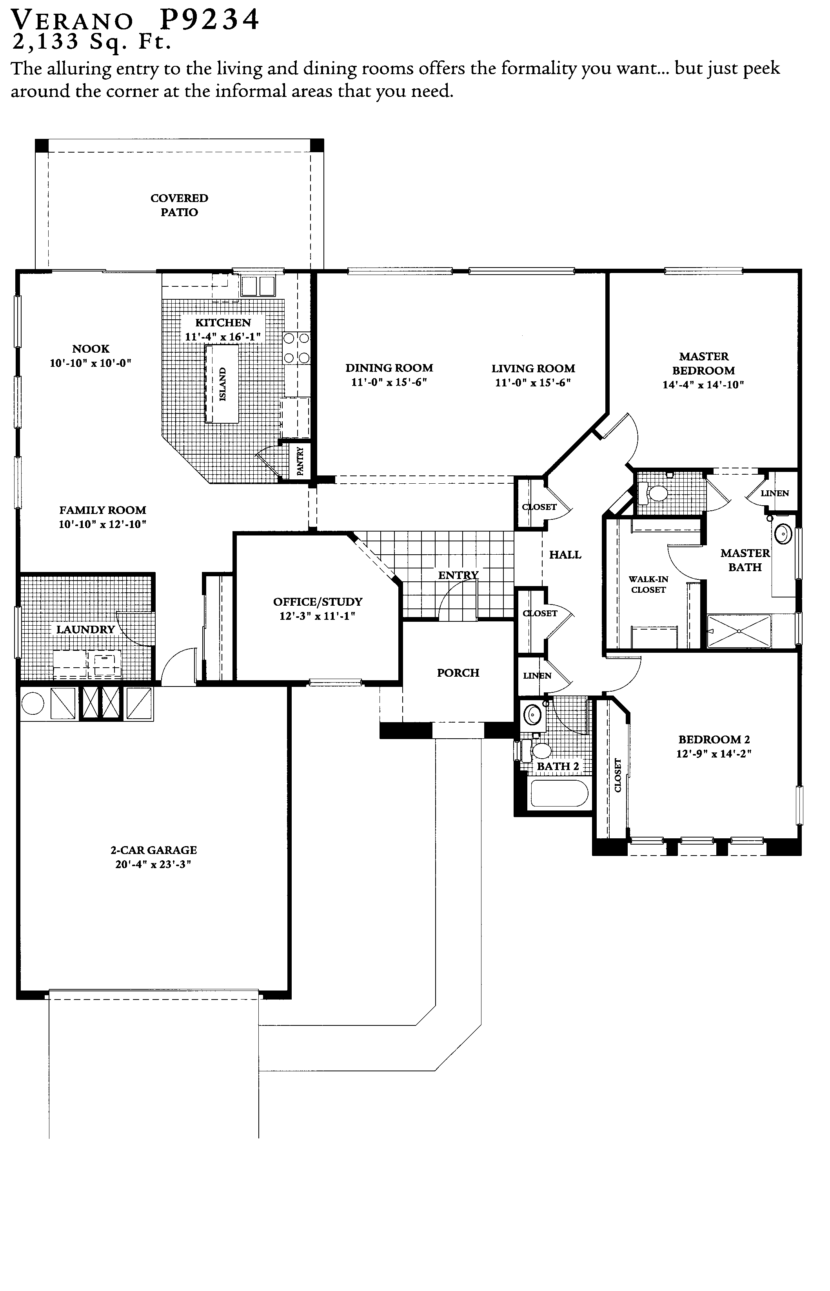
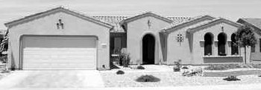
Lynn Verheul
623/221-5171

Similar Plan: Verbena, *Catalina
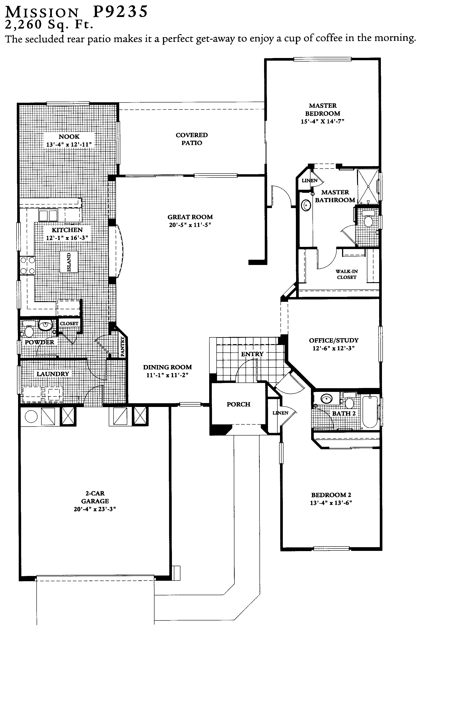
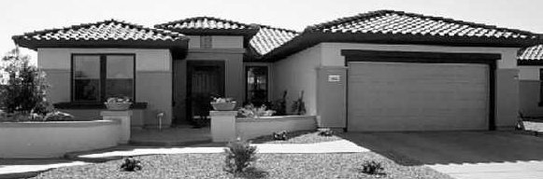
Lynn Verheul
623/221-5171

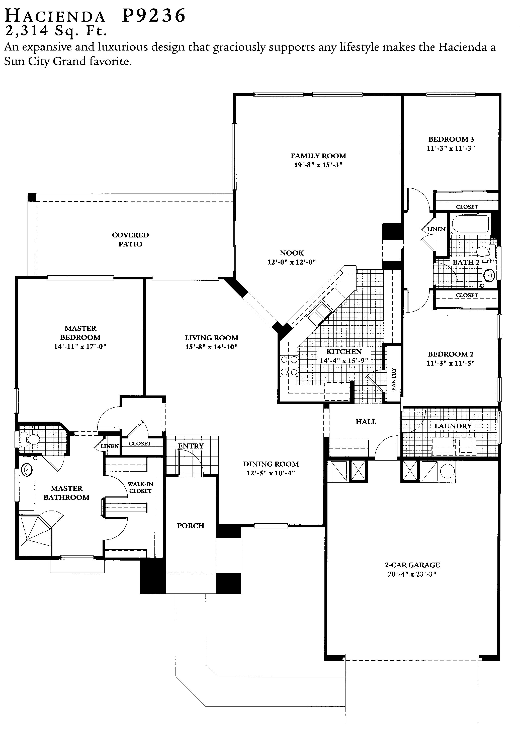
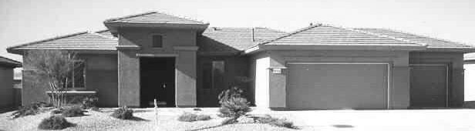
Lynn Verheul
623/221-5171

Similar Plan: Stonecrest, *Lakeside
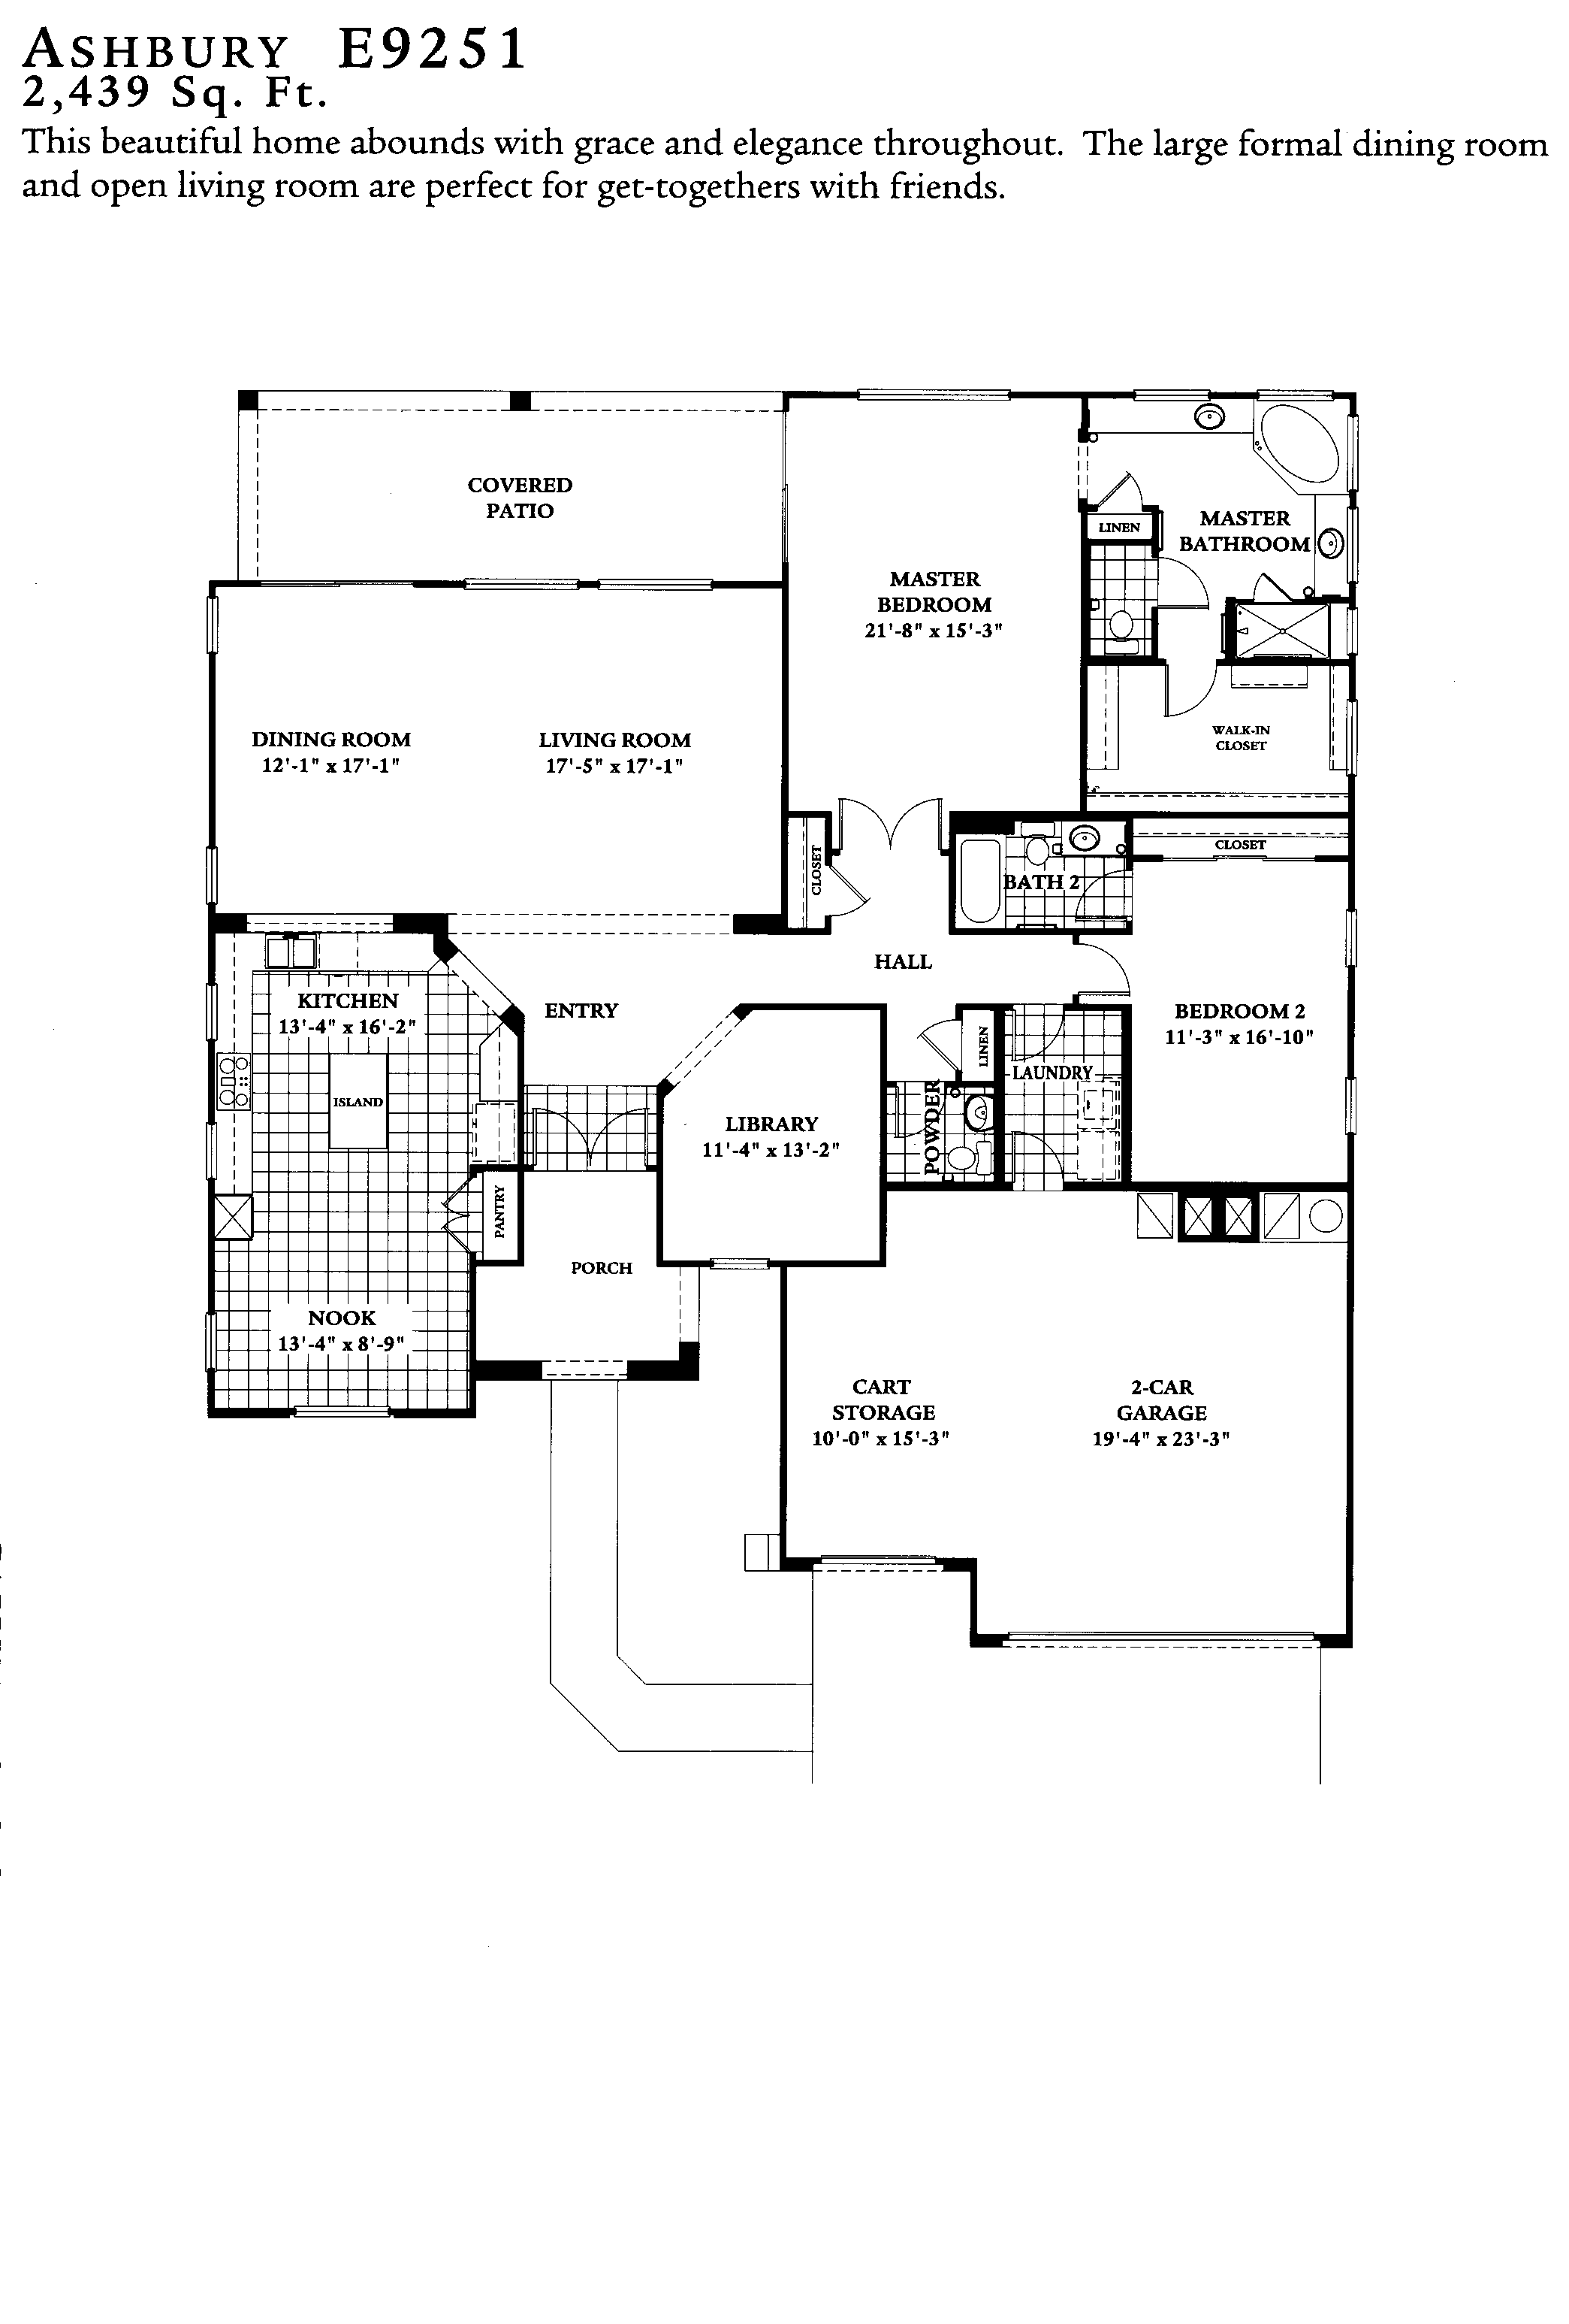
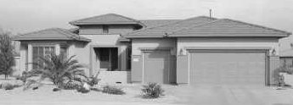
Lynn Verheul
623/221-5171

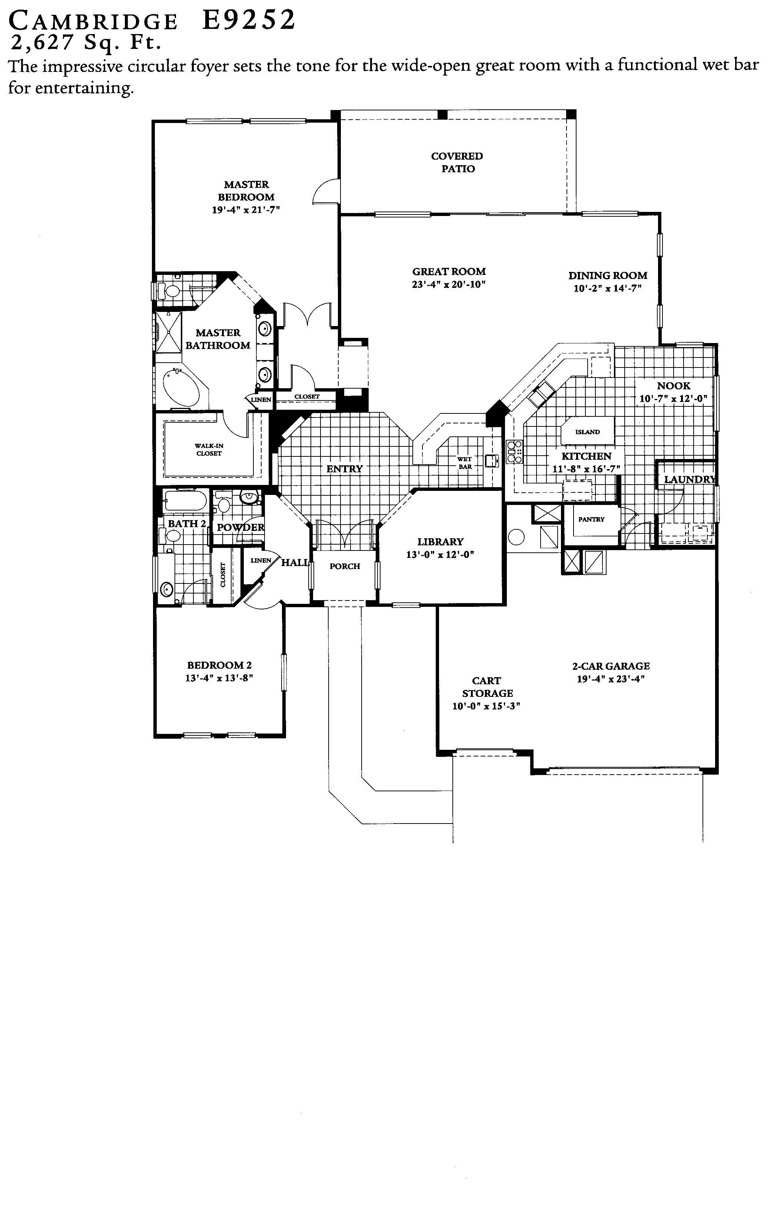
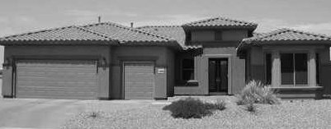
Lynn Verheul
623/221-5171

Similar Plan: Rosewood
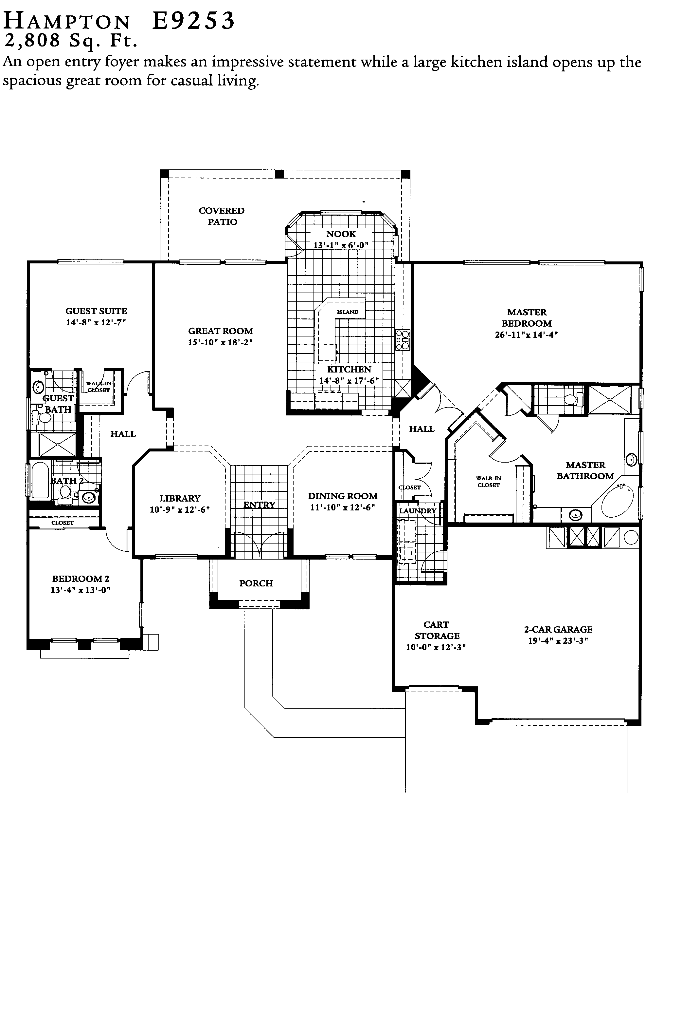
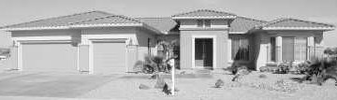
Lynn Verheul
623/221-5171

Similar Plan: Mesquite
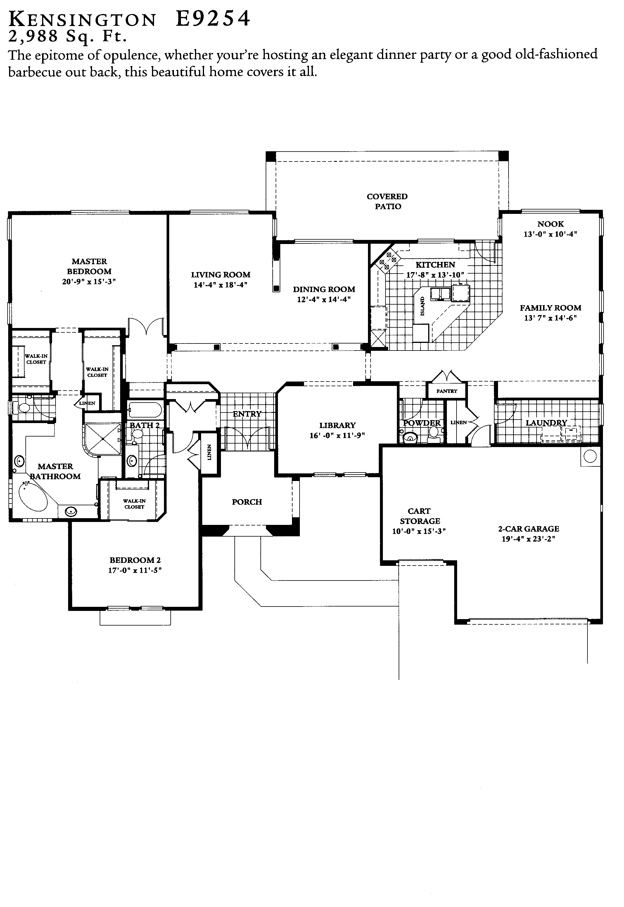
Lynn Verheul
623/221-5171

Similar Plan: Briarwood
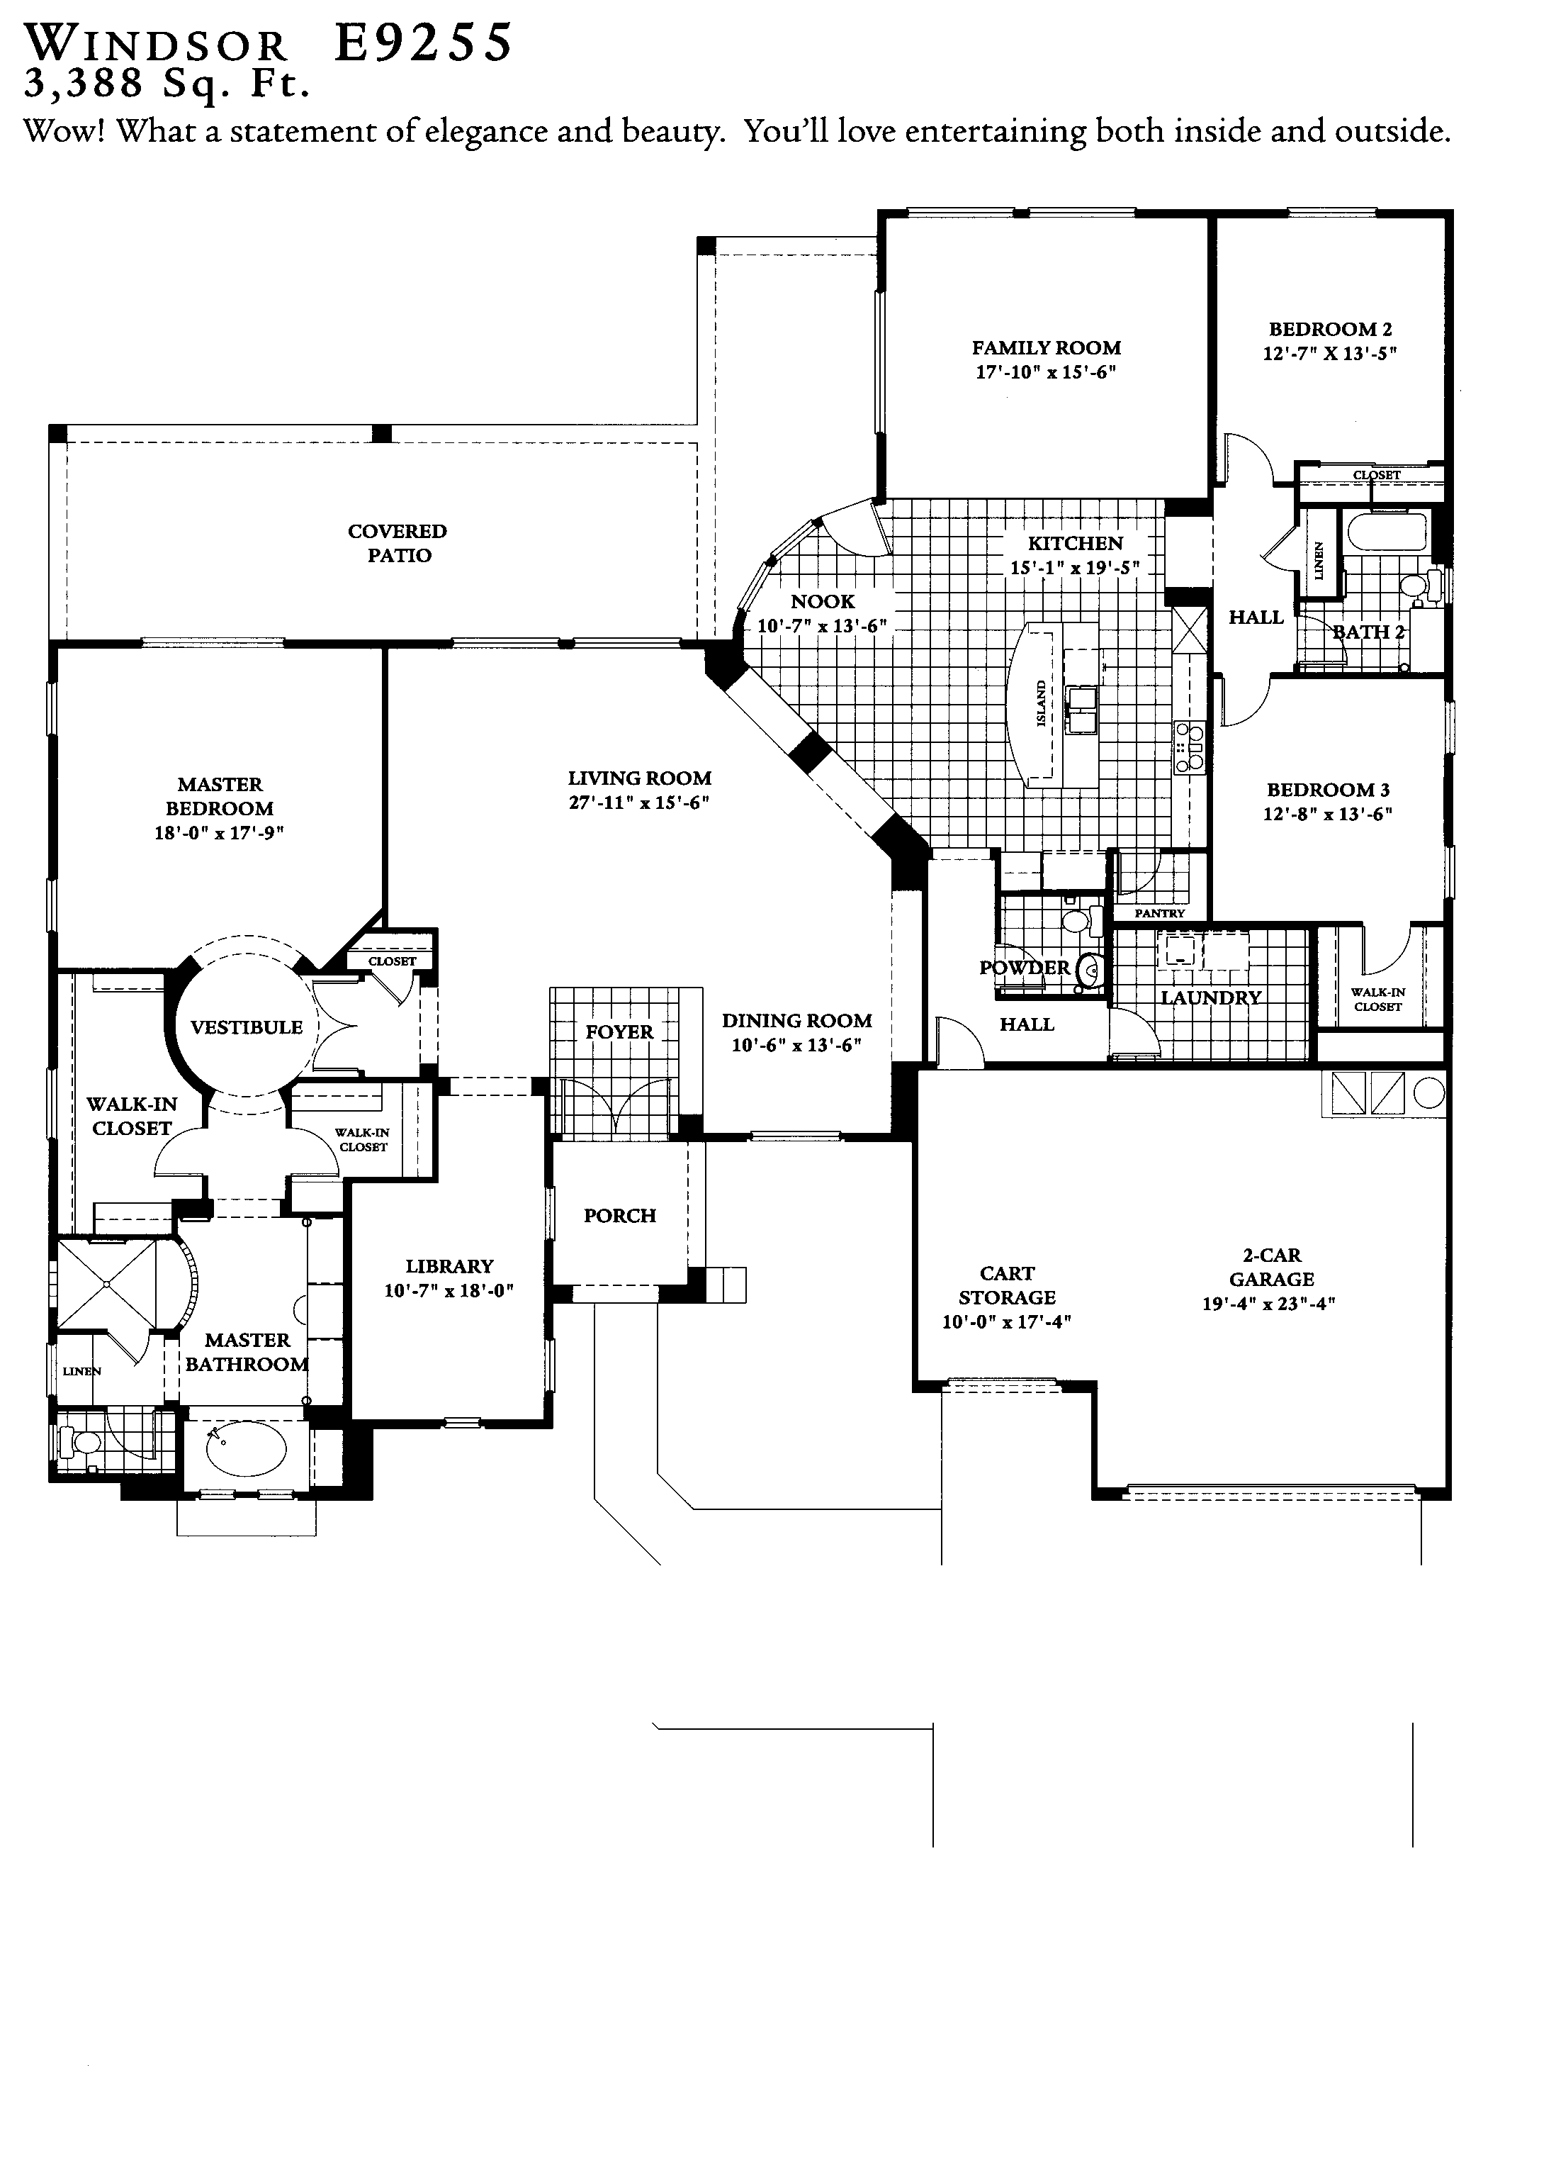
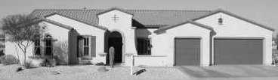
Lynn Verheul
623/221-5171

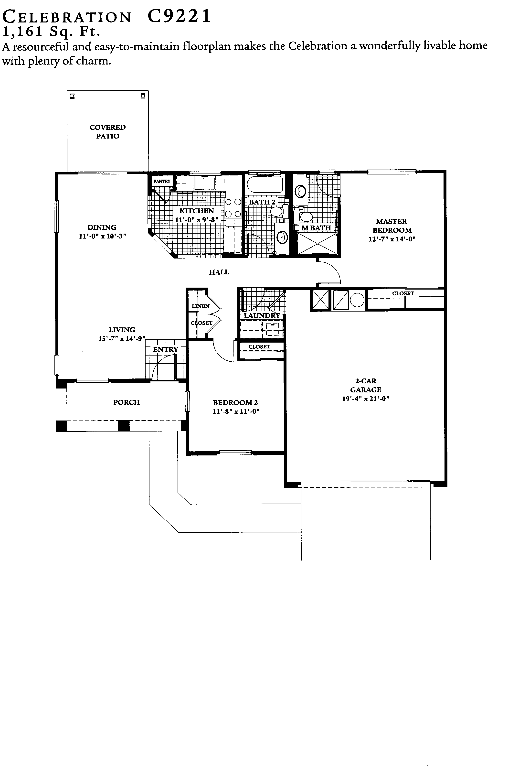
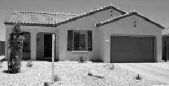
Lynn Verheul
623/221-5171

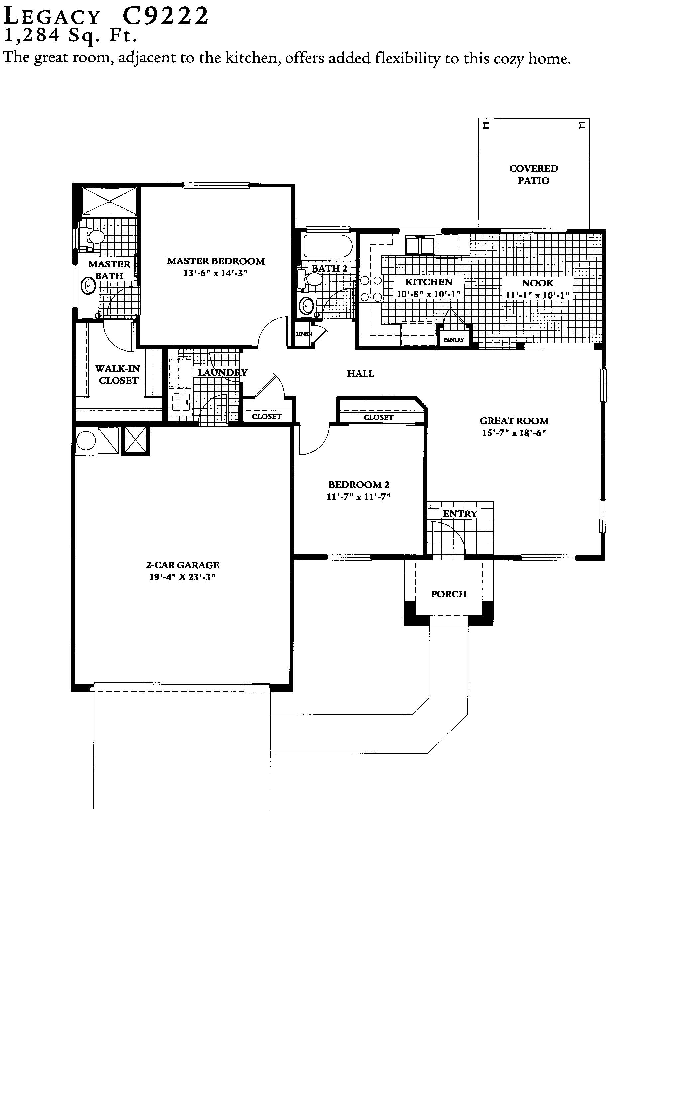
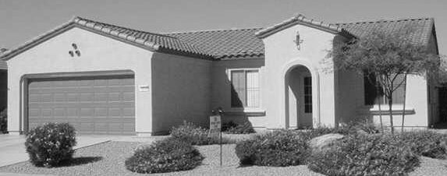
Lynn Verheul
623/221-5171

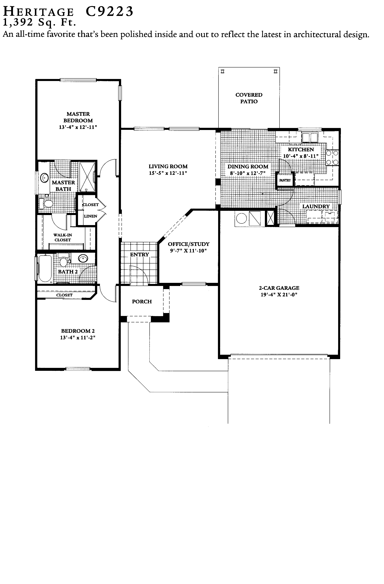
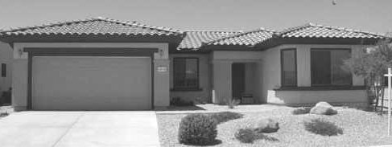
Lynn Verheul
623/221-5171

Similar Plan: *Alpine

